Steps to make a form using typo3

1. Go to form.Create a new form

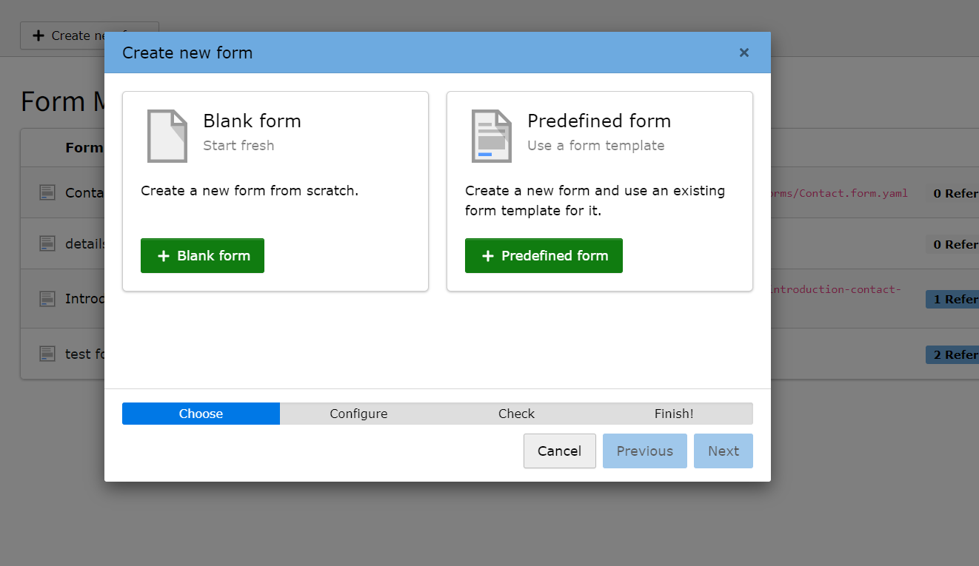

Name the form (it will create an yaml extention by default)

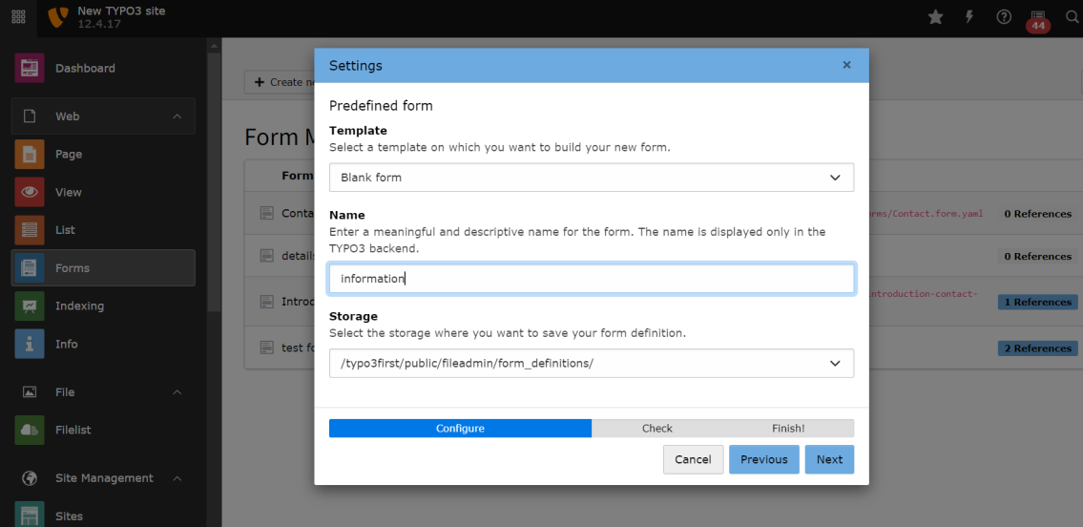

1. Add the desired elements(and save it)

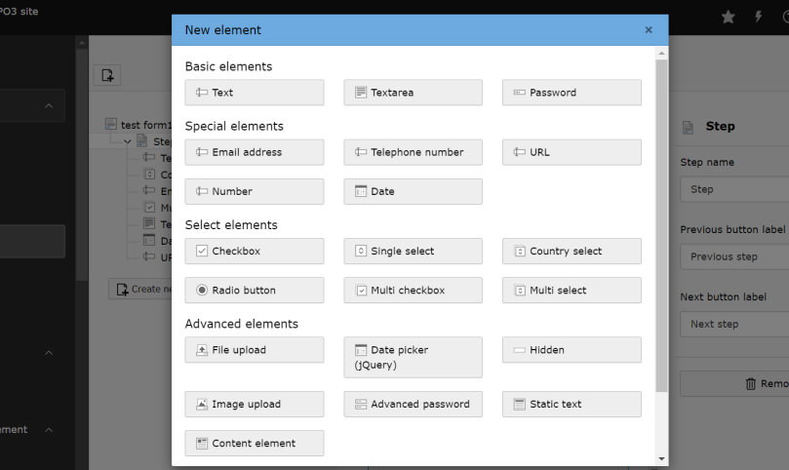

1. Go to page(create new element)

Go to plug in and add the yaml file.

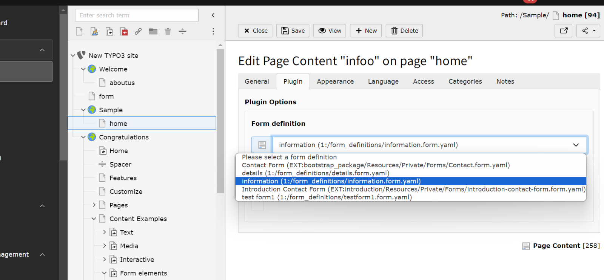

4)Go to your root page and select typo script.

And edit your typo script record in the advanced option choose the form and contents package.

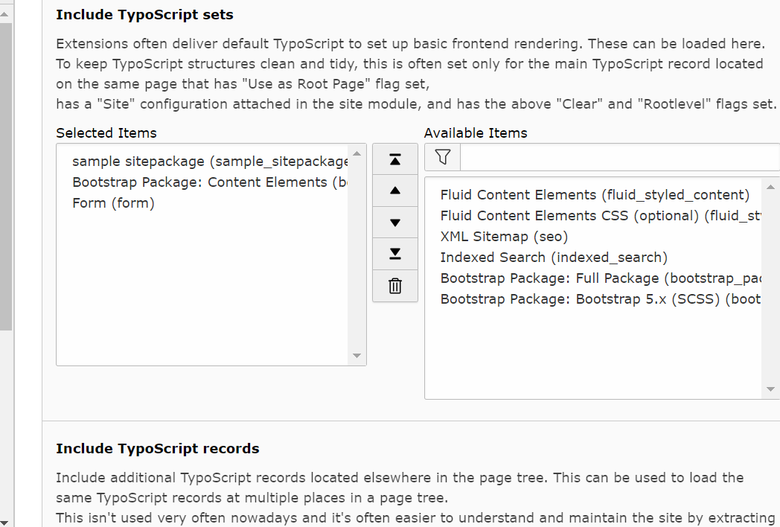

5)Save it and view the page.

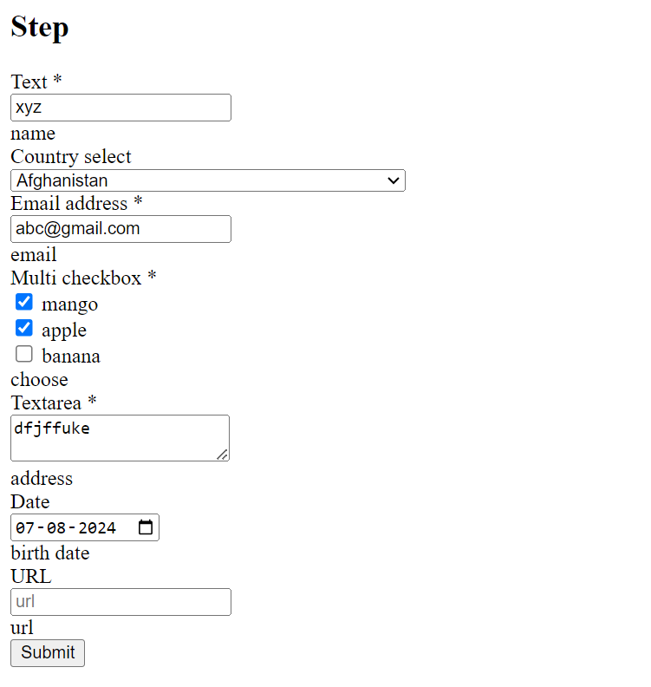

To install site package

* Refer to this link

<https://sigalambigha.home.blog/2019/04/24/installing-a-site-package-when-typo3-is-in-composer-mode/>

"repositories": [

        {"type": "path", "url": "packages/*"}

    ],

You can name the site package as you wish.

C:\wamp64\www\typo3first\packages\samle_sitepackagae

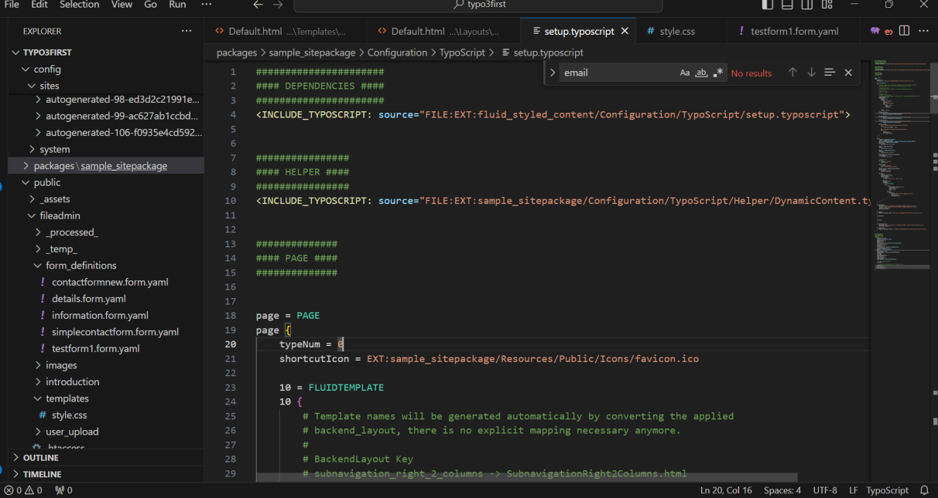

To get nav bar

Must download bootsrap package.(to install css and js)

<https://www.youtube.com/watch?v=deSMVfCSCXY&list=PL-sDBIrOKGOZF7LK7Pcq2kH7FpbKvFsgK&index=2>

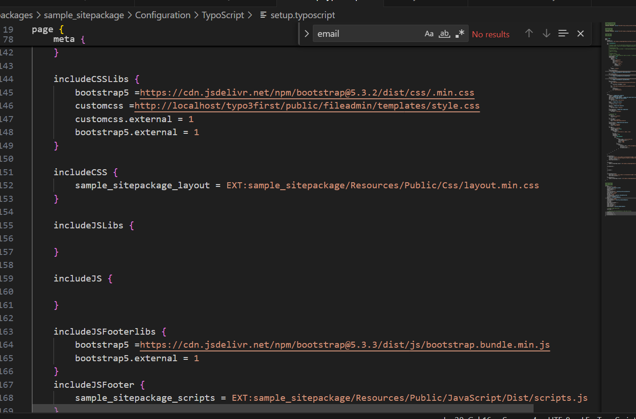

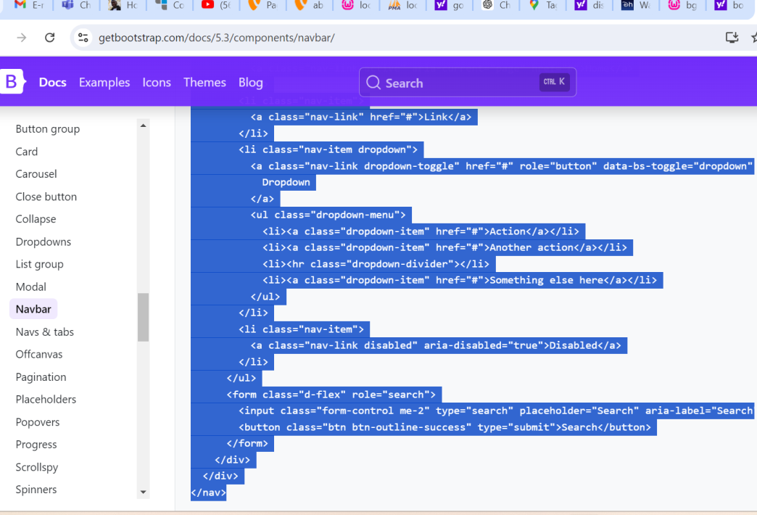

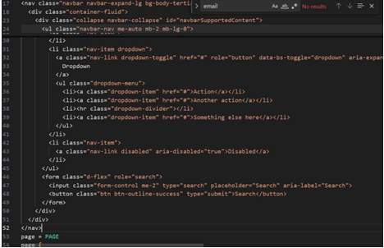

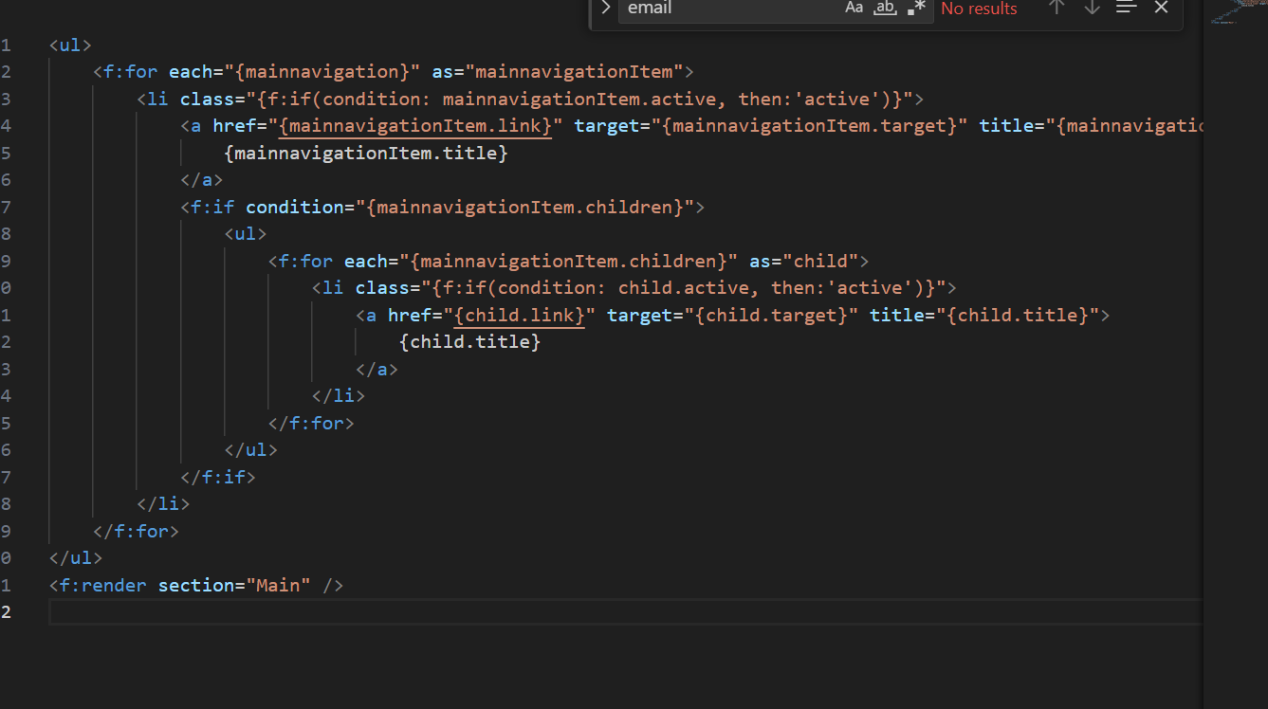

To reflect the data after submitting the form

Tried connecting typo3 and database. Connected that successfully.

To get the data reflected in the database after submitting downloaded extentions.

Under typo3conf created a new folder “ext” under that folder “amrita” and ext_emconf.php

Public/typo3conf/ext/amrita/ext_emconf.php

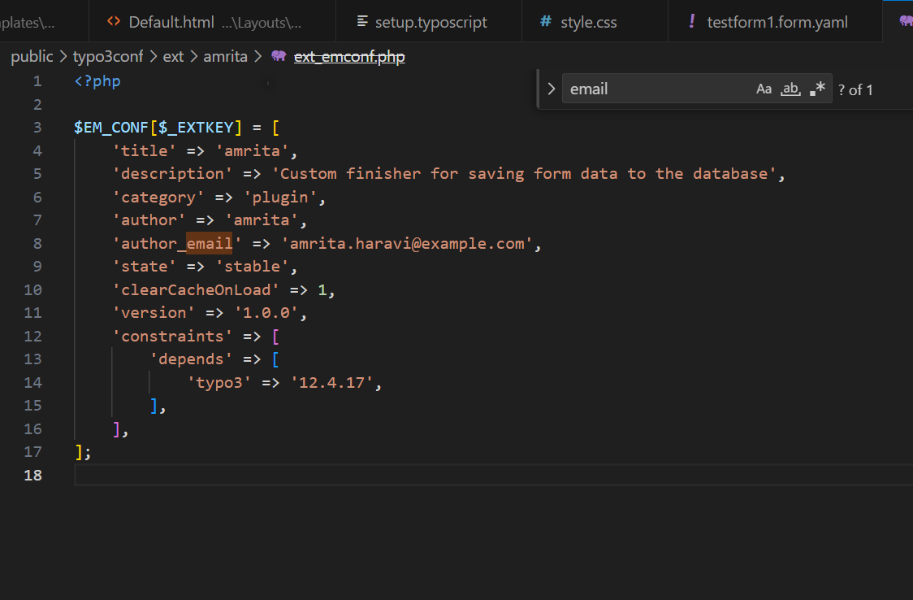

Added finisher “savetodatabase” class after creating ext_localconf.php

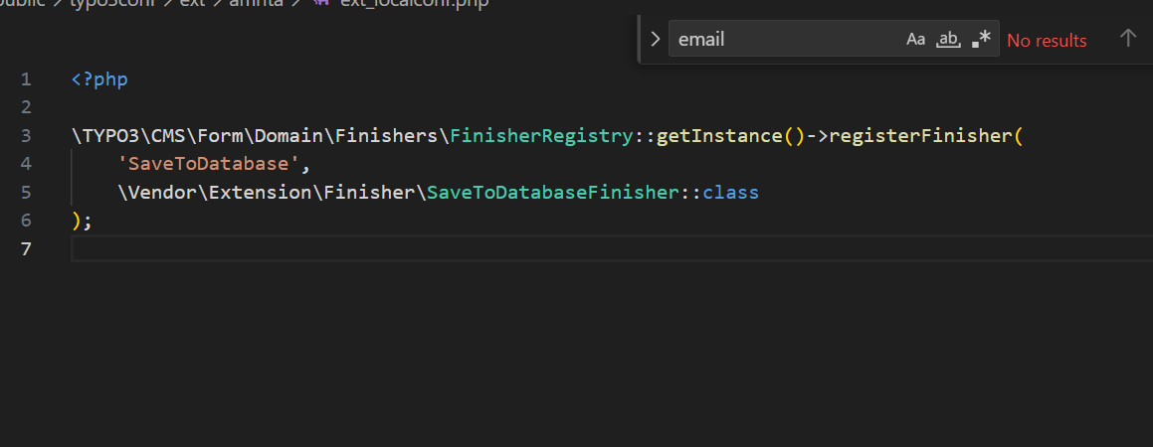

Created own table in the server and made the form structure match the structure created in local server and connected in the backend.

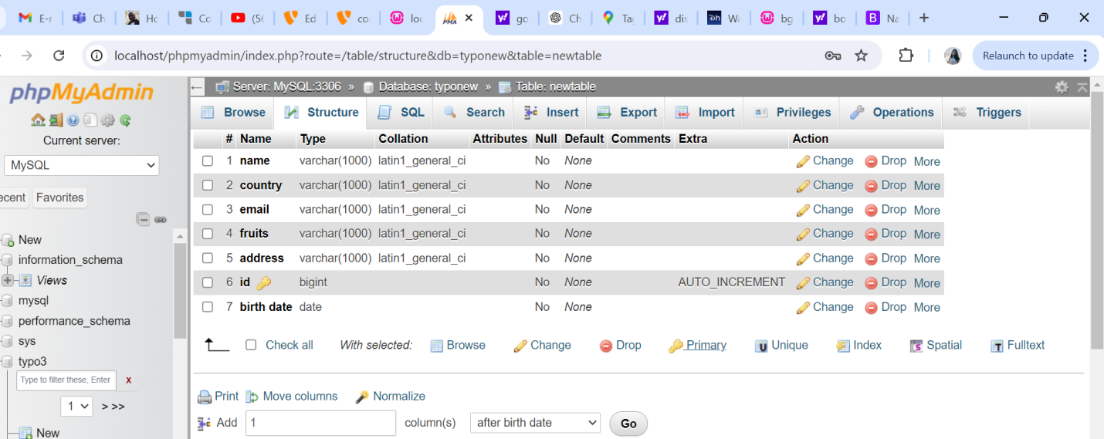

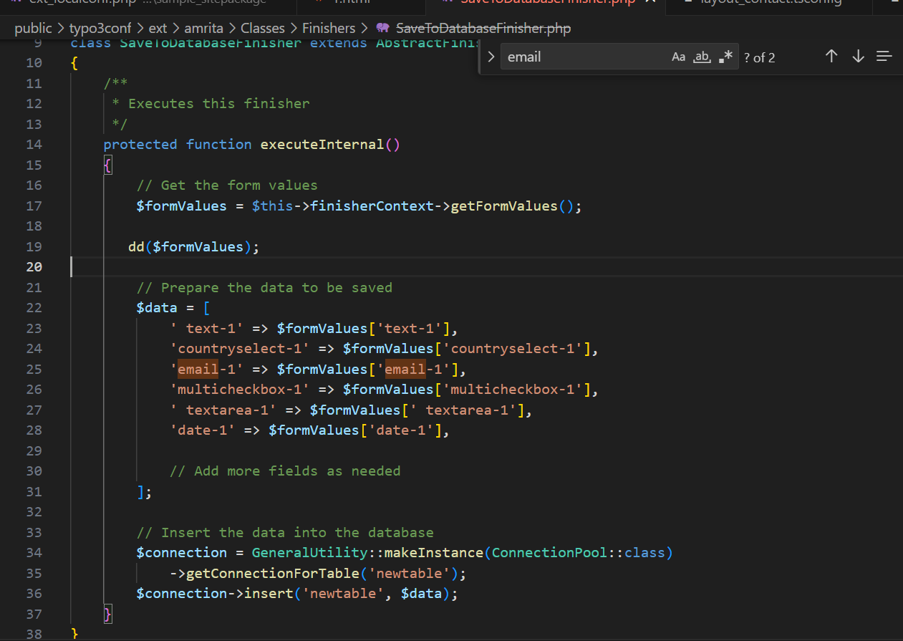

Error :But error occurred when this particular form was selected hance couldn’t see the backed of the form(typo3).

Sol: The error was fixed after changing syntax code of the code and appropriate fieldname and structure below.

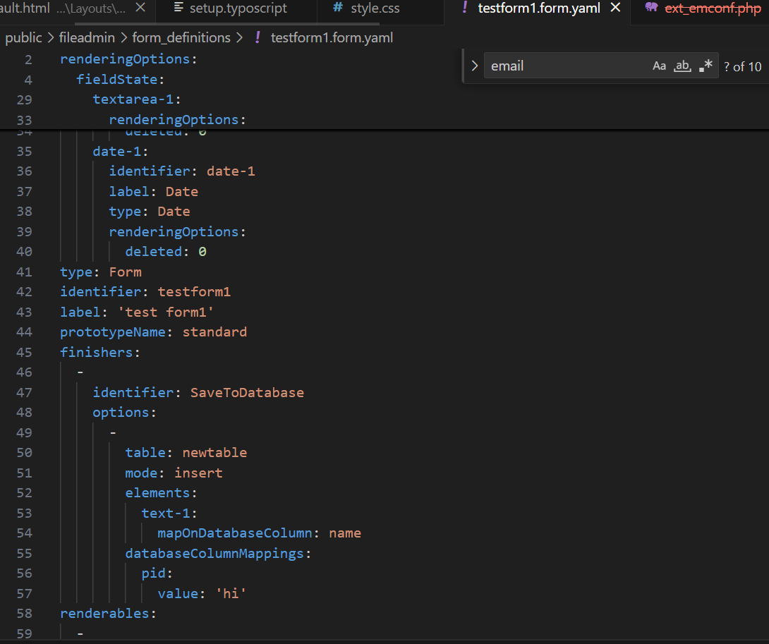

The error was fixed and now could see the backend of typo3 for forms. And a new option occurred “Form Results”

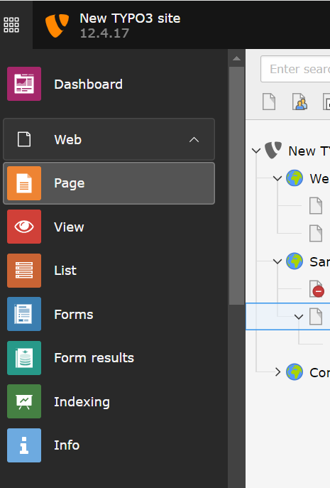

Inspite of getting form results,after submitting the form the form data wasan’t being reflected.

To create a new root page

Error:

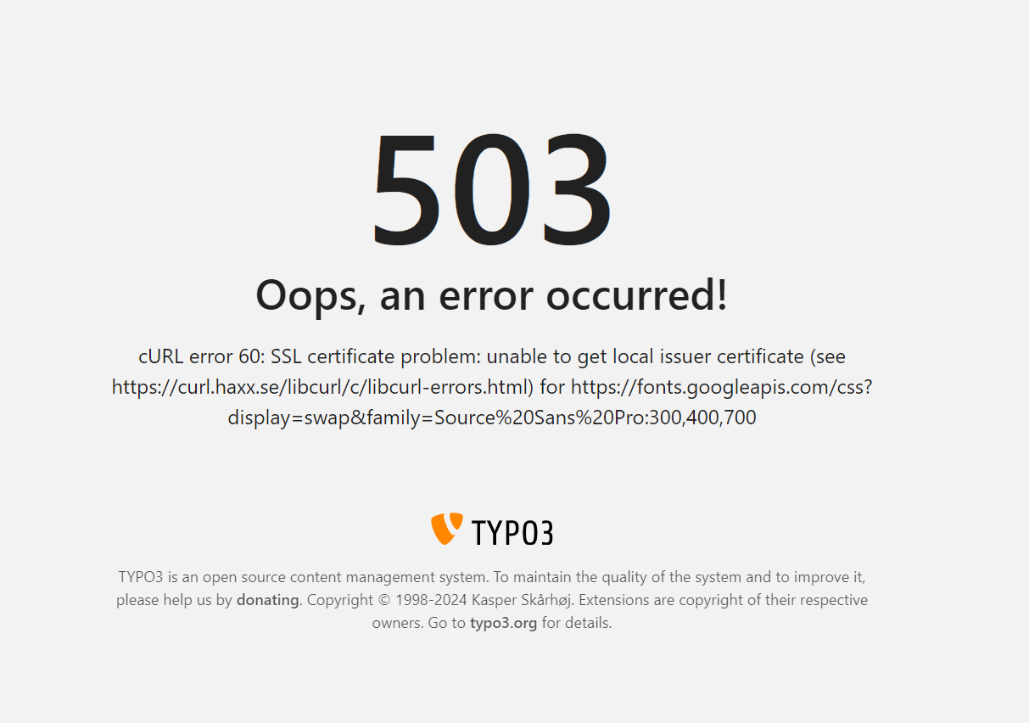

Sol:

Always create install a new sample package for every root page. Output will be seen in the frontend.

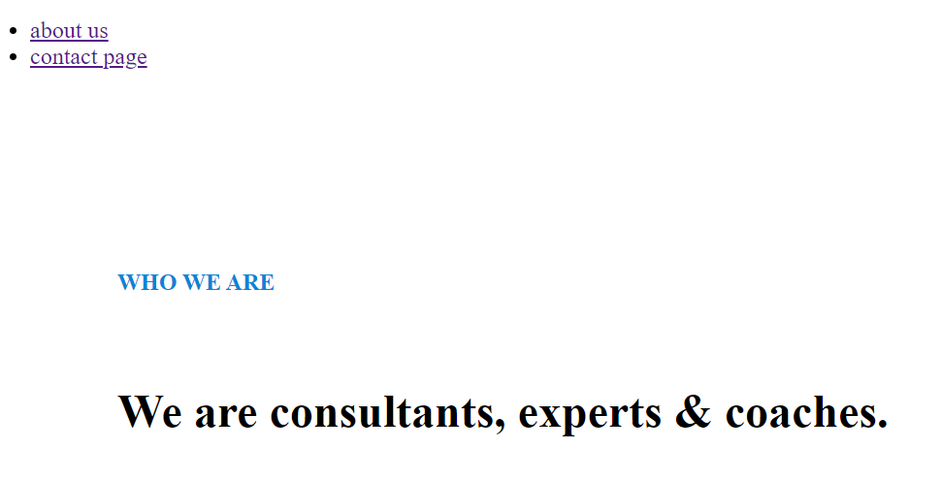

To make customized backend layouts

* Refer to this link

<https://www.liquidlight.co.uk/blog/creating-backend-layouts-with-typo3-cms-to-build-better-looking-pages/>

steps

1. Go to list and “create new record”

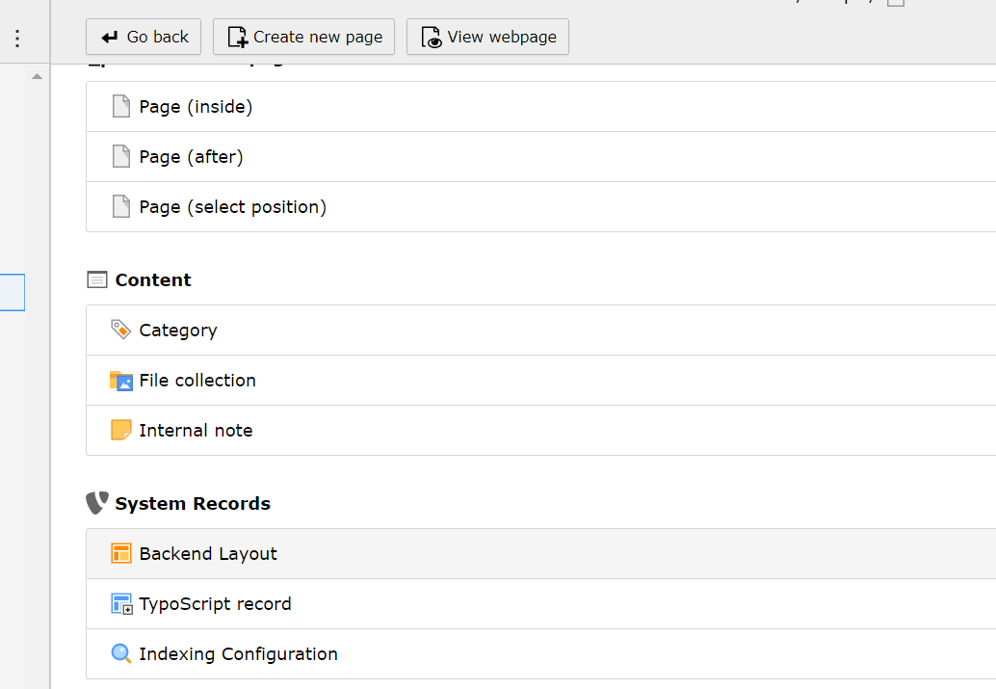

1. Customize your layout and make sure you name the columns. And save.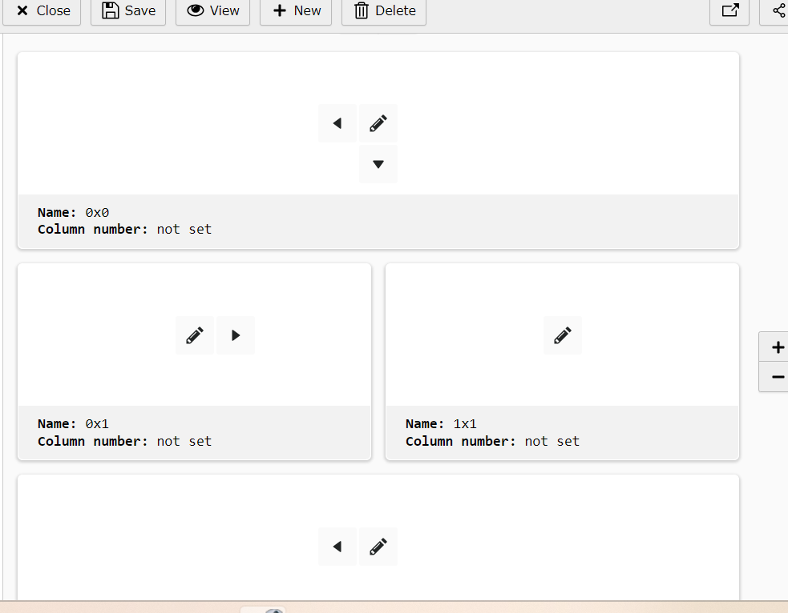

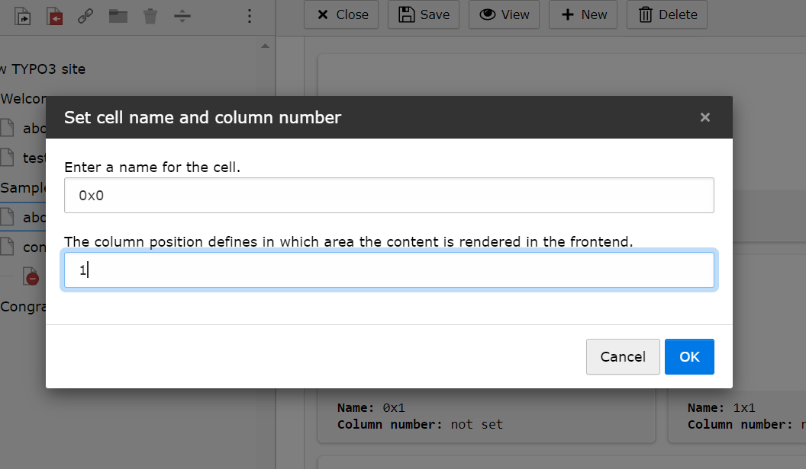

1. Copy the code that is generated.

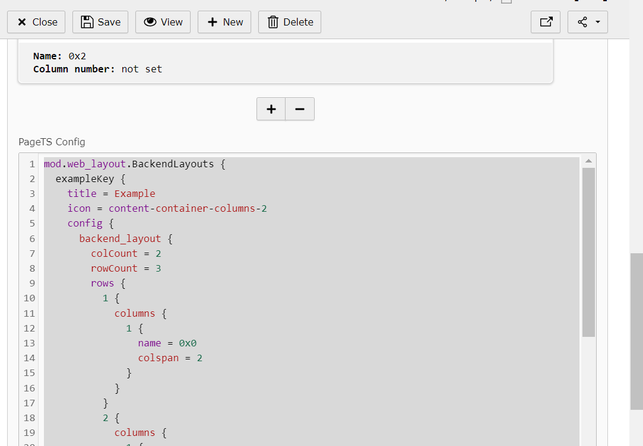

@import 'EXT:[extension_name]/Configuration/TsConfig/Page/Mod/WebLayout/BackendLayouts’

1. Create new file with the customized layout name given before layout_contact.tsconfig and paste the above code here.

Change the title name(should follow camelcase and no space).

Above that give the name given for your template

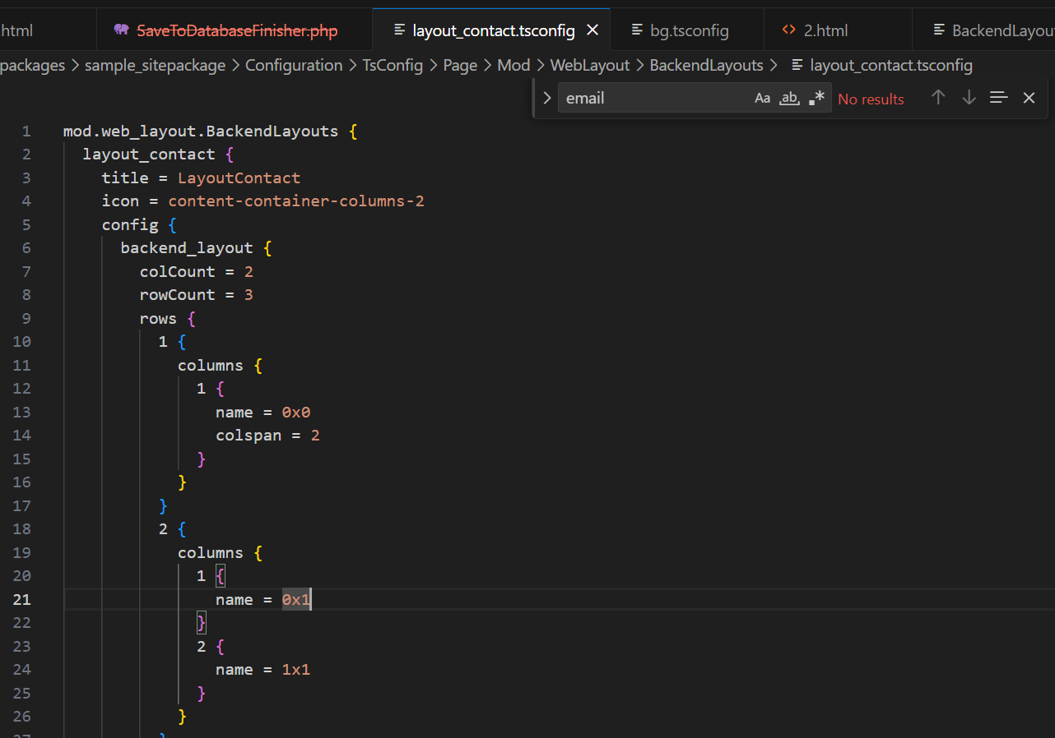

1. Create a new html file.

Packages/sample_sitapackage/resources/private/templates/page/1.html

File name must be the id no.

For file name: Hover on the icon id no will be displayed.

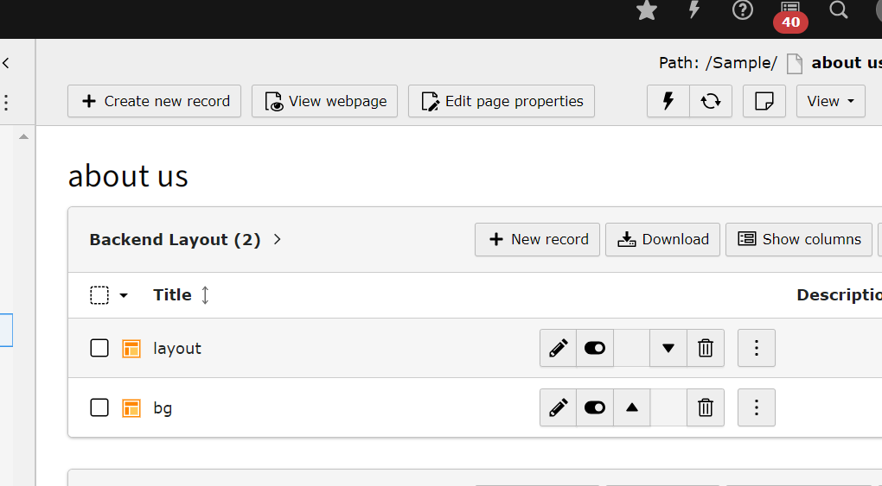

1. Go to default html and copy the code and paste in 1.html.

Packages/sample_sitapackage/resources/private/templates/page/default.html

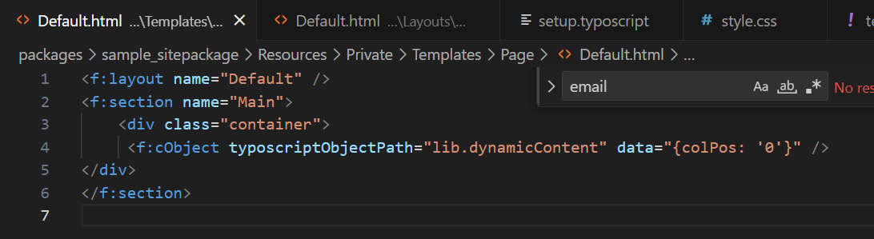

7) In this file paste the html code for the desired template and change the colpos no according to the given before.

Packages/sample_sitapackage/resources/private/templates/page/1.html

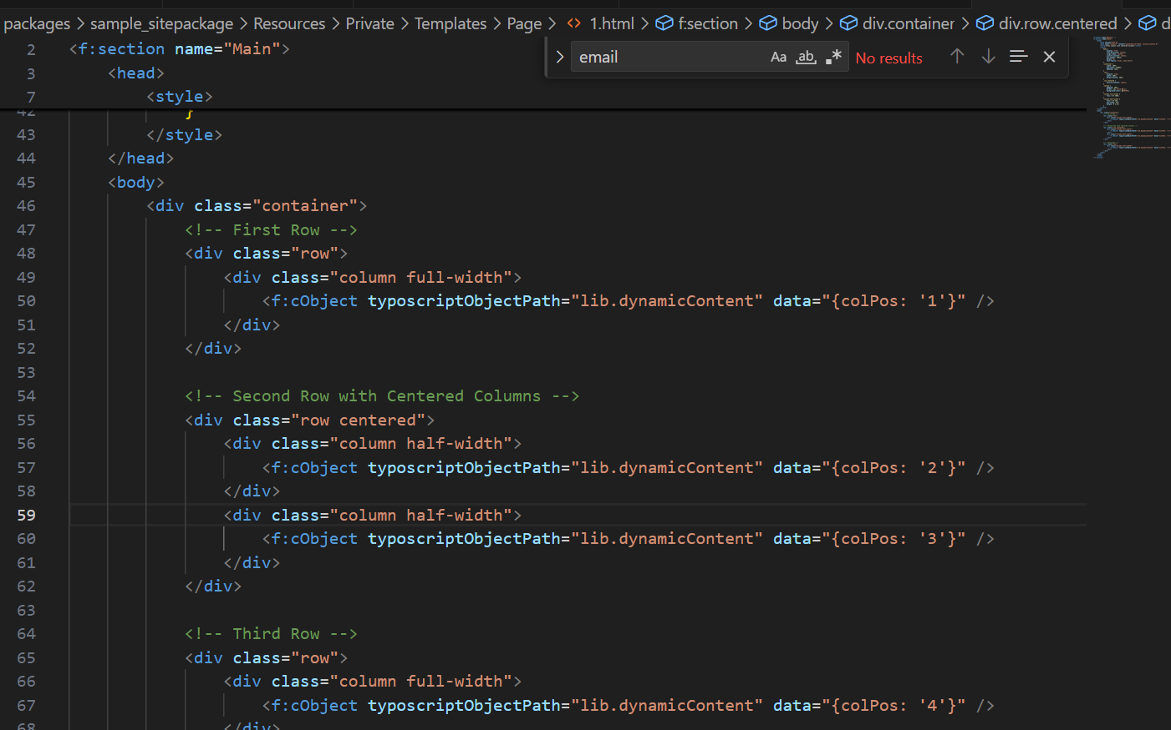

8)copy this

\TYPO3\CMS\Core\Utility\ExtensionManagementUtility::addPageTSConfig('@import "EXT:my_sitepackage/Configuration/TsConfig/Page/Mod/WebLayout/BackendLayouts.tsconfig"');

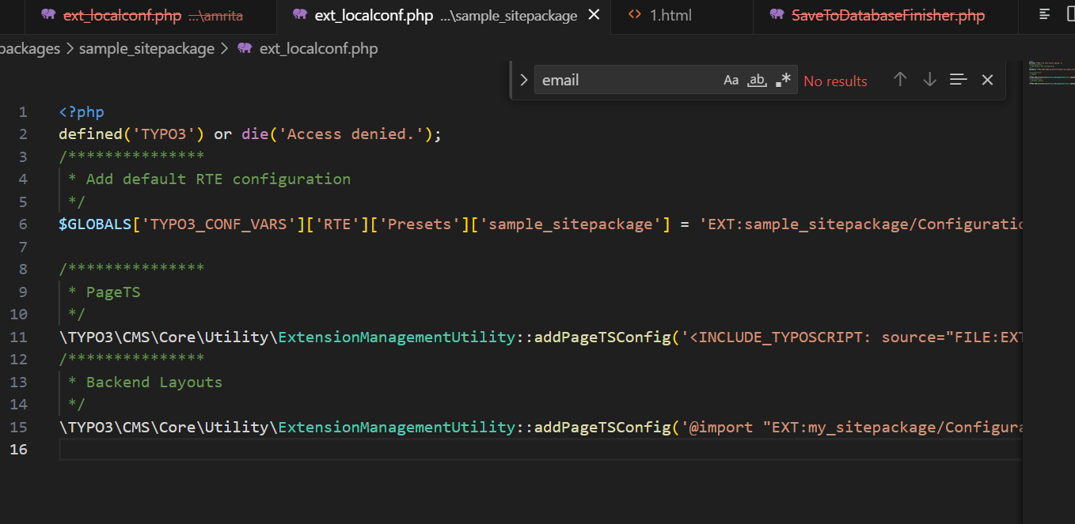

9) Go to form and edit page properties (appearance) select the layout you created.

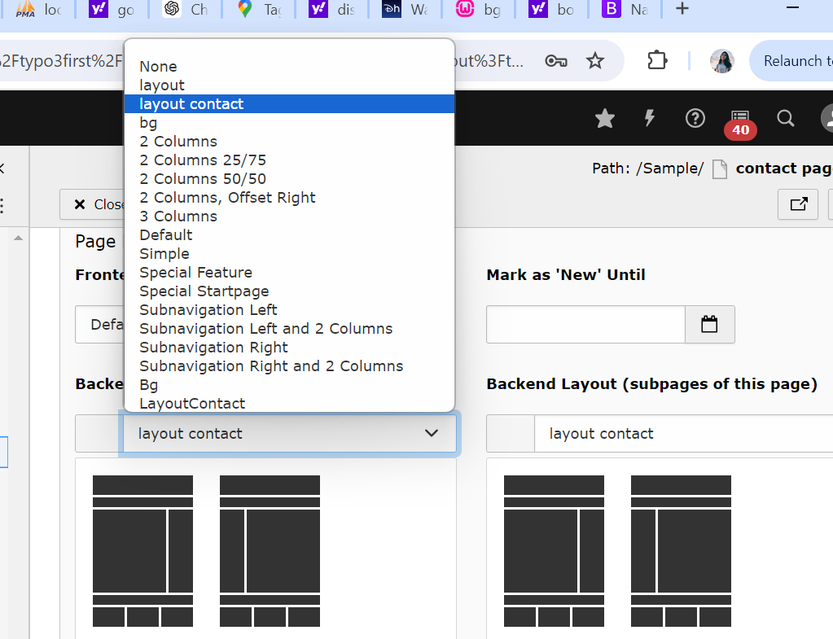

Desired layout is created. The size increases as you add content.

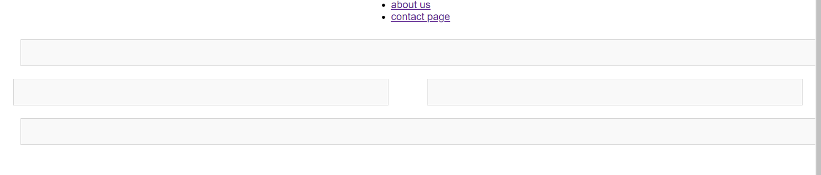To add map

1. Search for the desired location on google map and copy the iframe link.

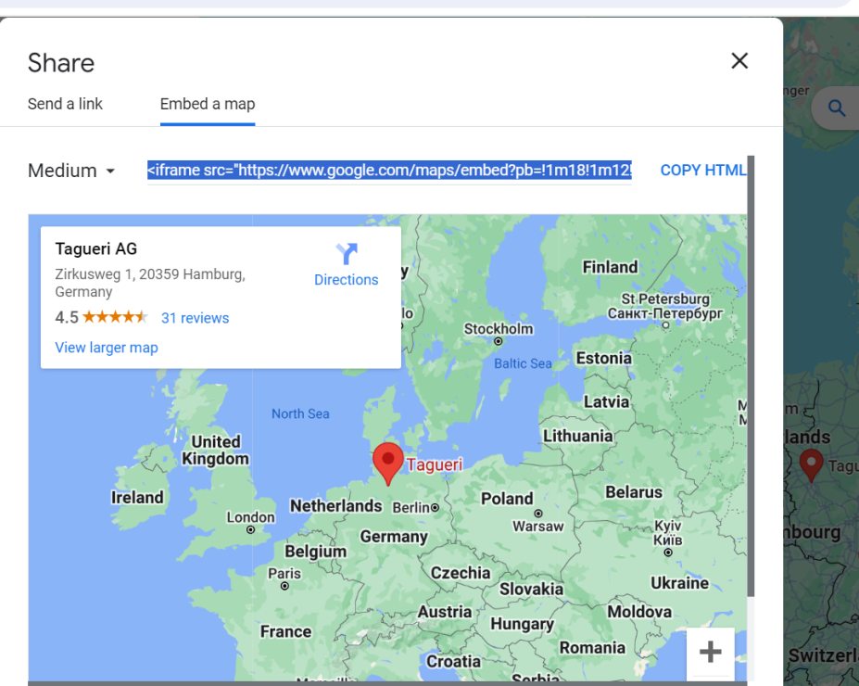

1. Choose plain html.

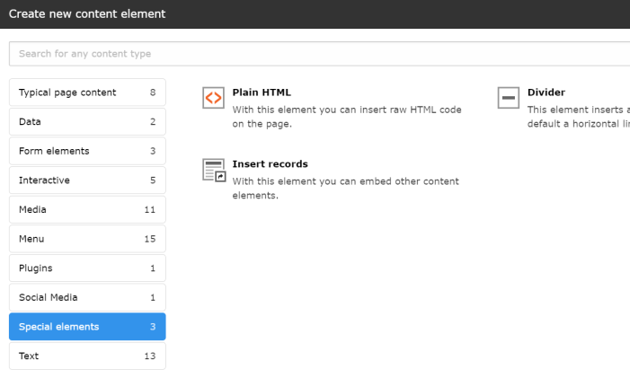

1. Add the copied iframe link here and save.

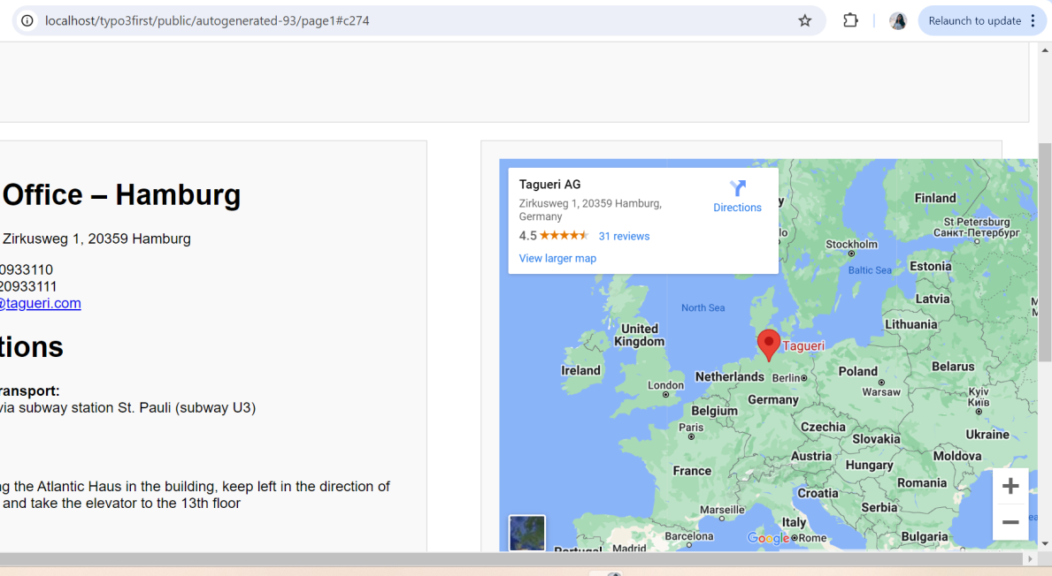

Contact us page(tagueri)

1)Create the desired template and select that.

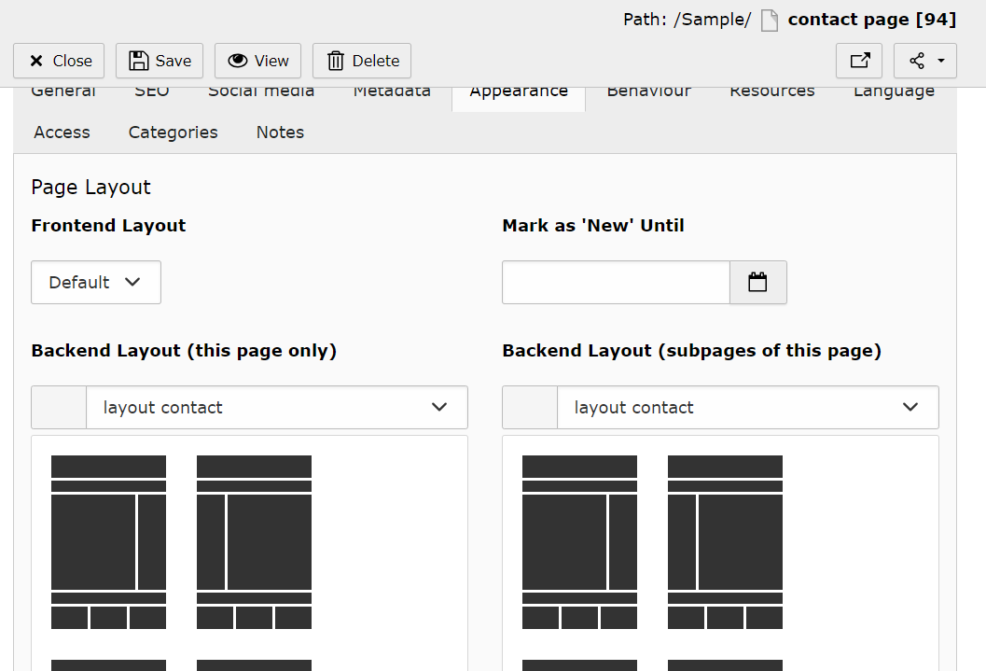

2) Create a contact form from the form section.

And add confirmation text.

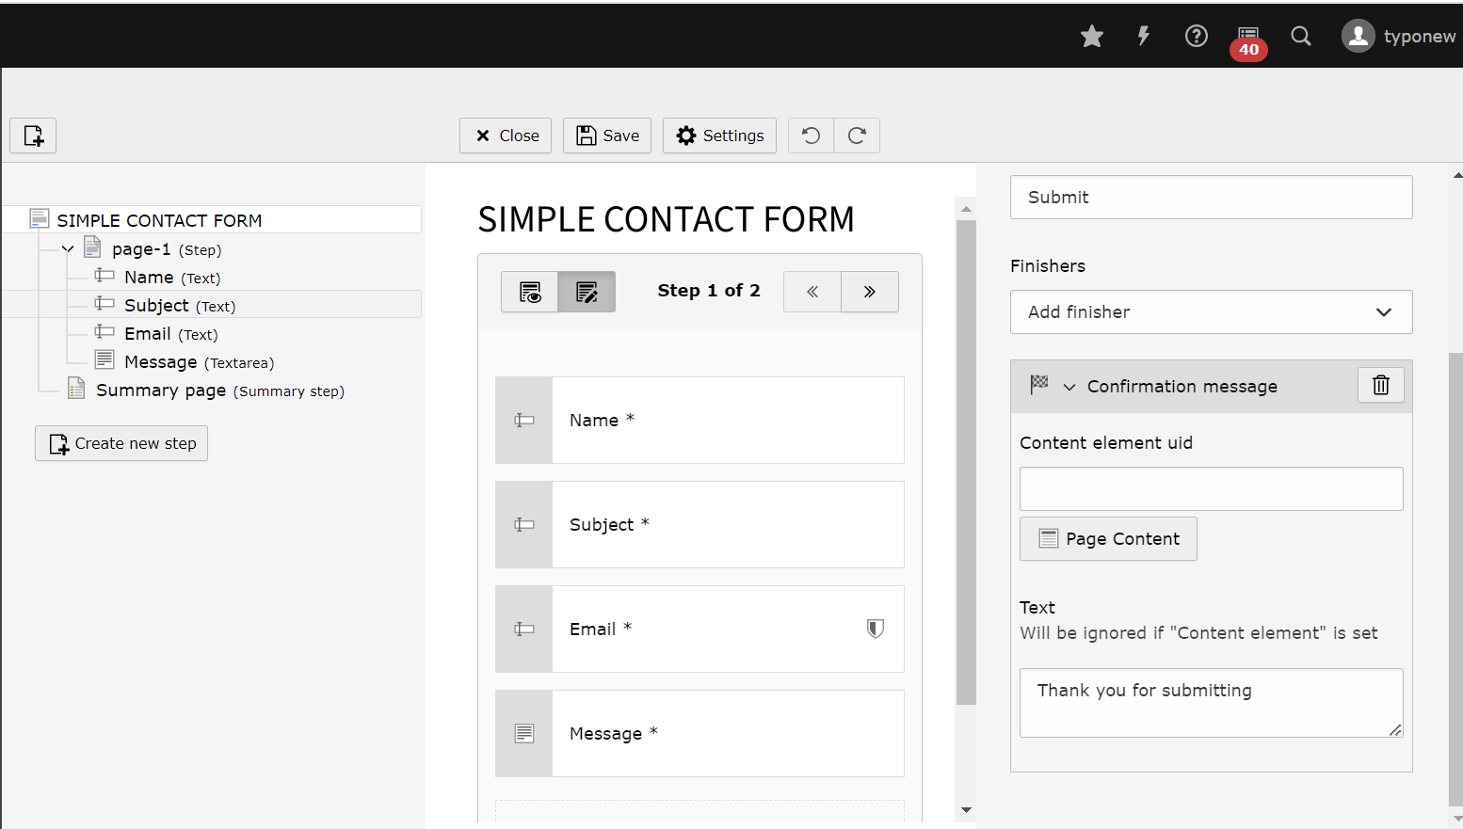

1. Add the content.
2. Save and view the page.

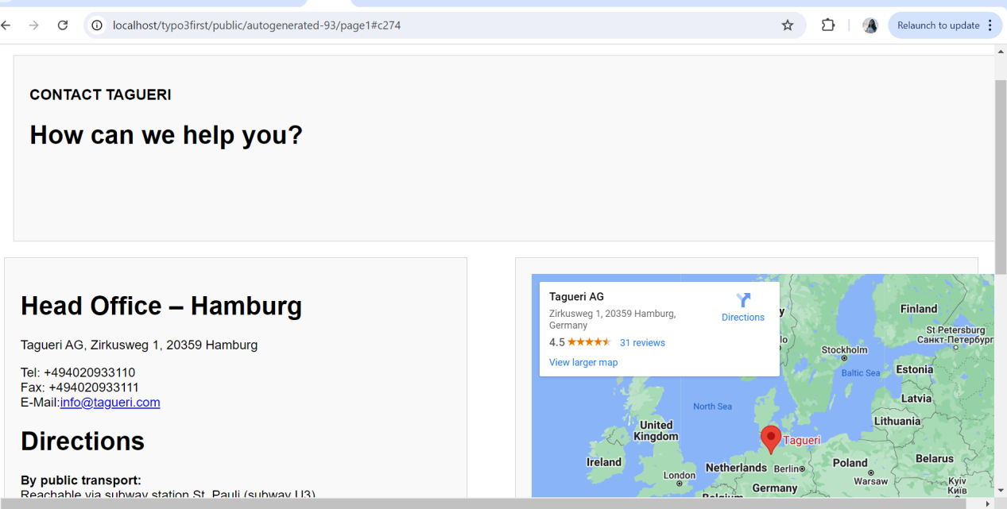

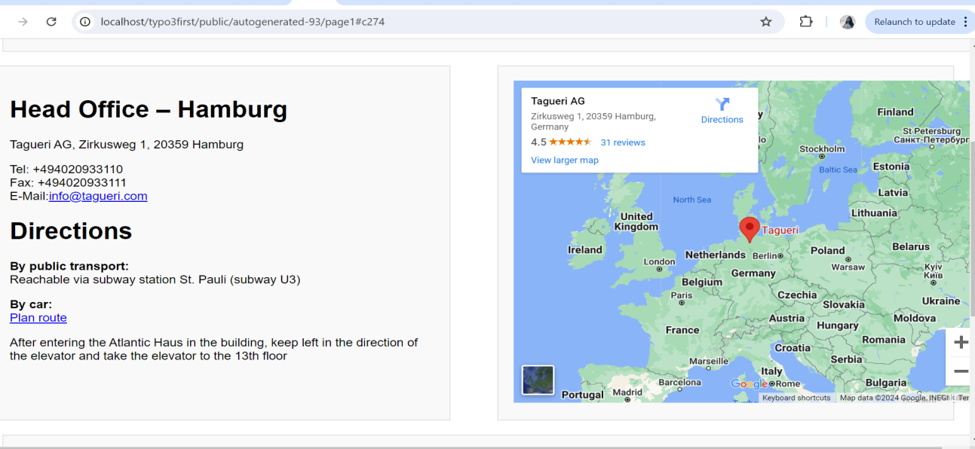

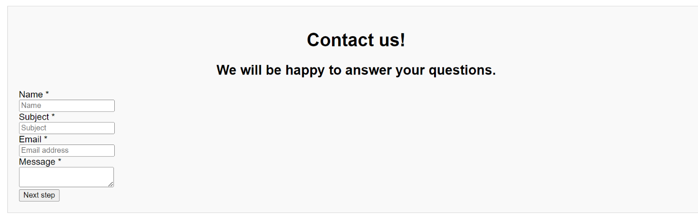

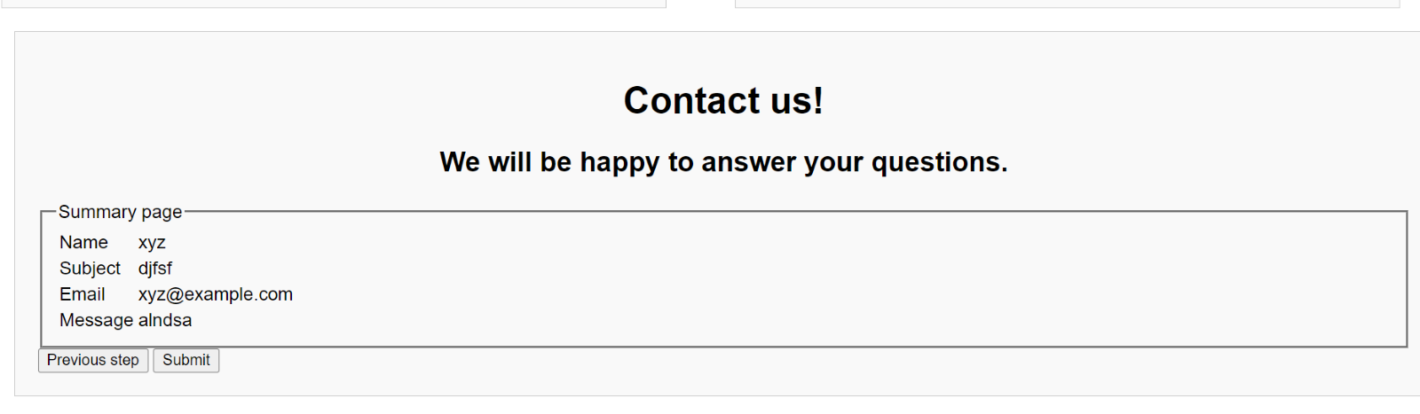

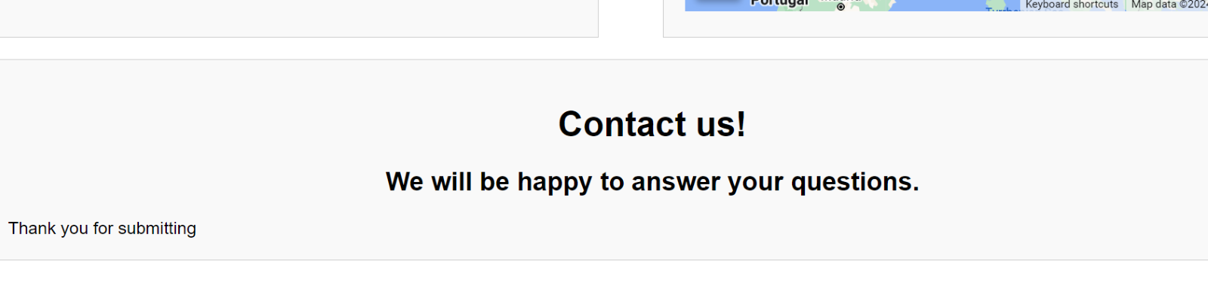

Modified contact page without summary page

1. In the backend paste the code in html.

Packages/sample_sitapackage/resources/private/templates/page/1.html

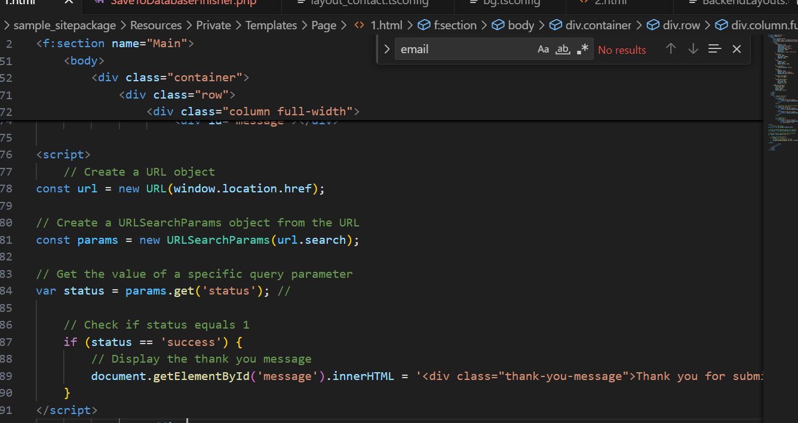

2)Go to form and under settings choose add finisher(redirect to a page)

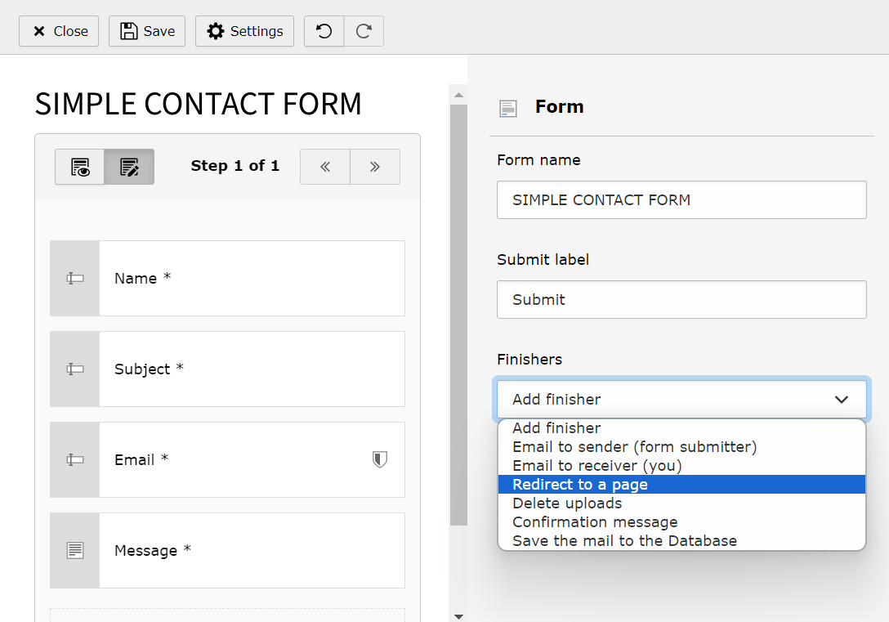

3) Choose the page you want re-direct to.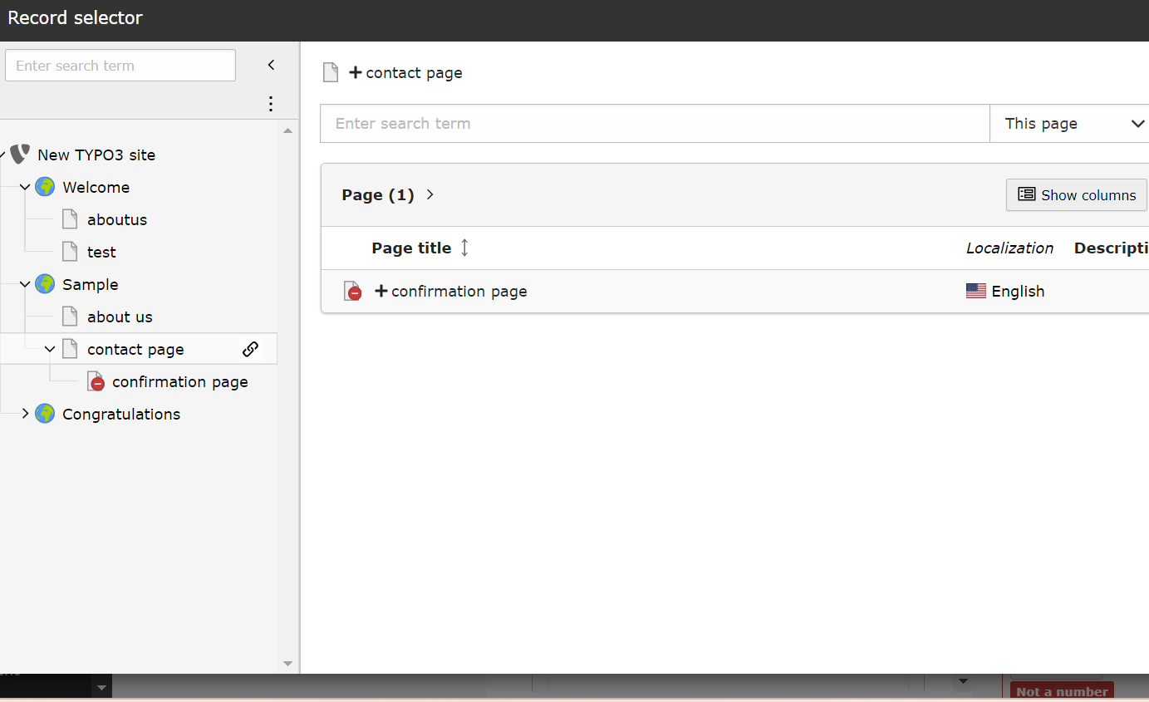

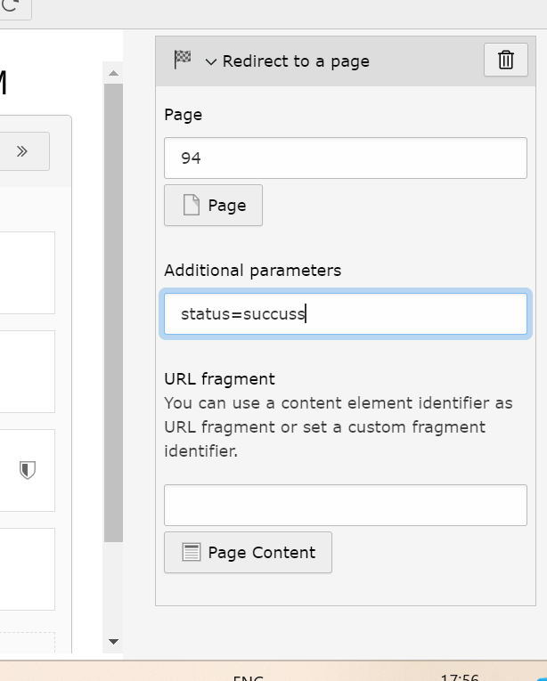

Save it.

Recaptcha

* Link: <https://www.youtube.com/watch?v=2xWDcNhZjrY&t=104s>

1. Go to command promt and download this recaptcha extention for typo3(in the folder composer.json file is located.)

composer req evoweb/recaptcha

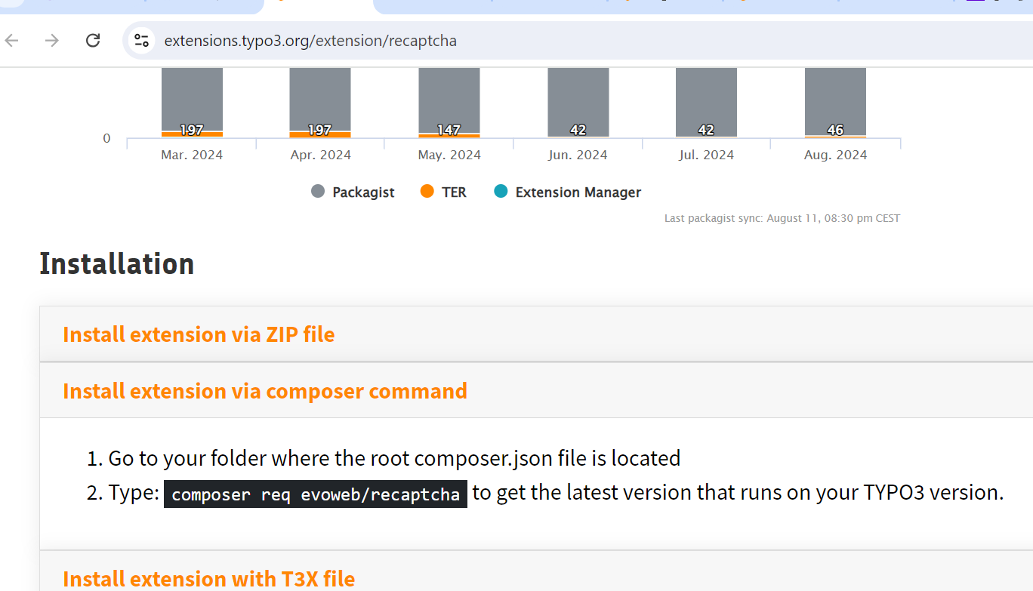

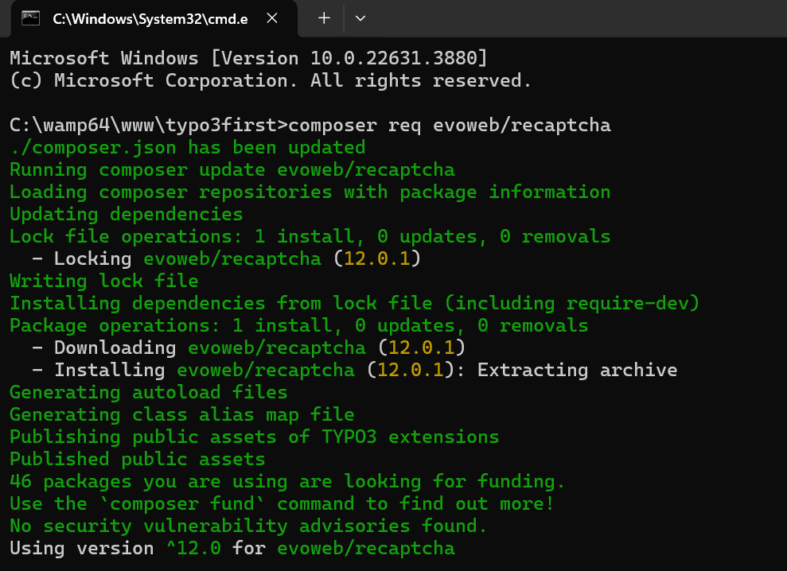

1. Go to forms and edit the form by creating new element.(in the advanced option the recaptcha is shown)

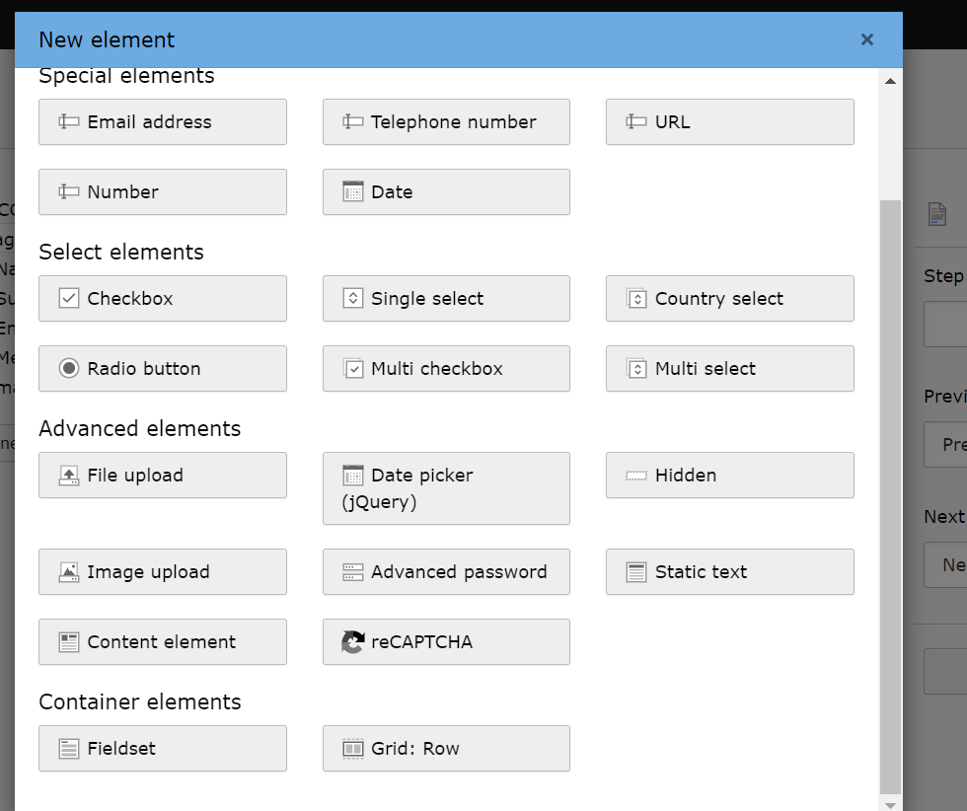

1. After choosing the element save it. And go to the typoscript and add the recaptcha extension.

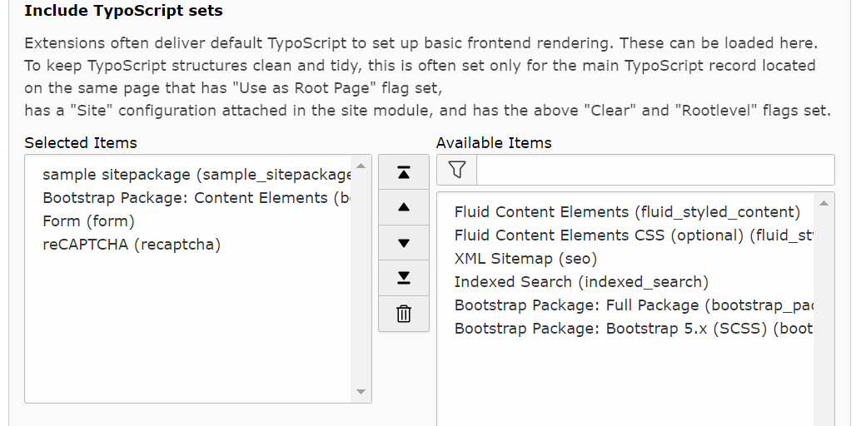

Error:

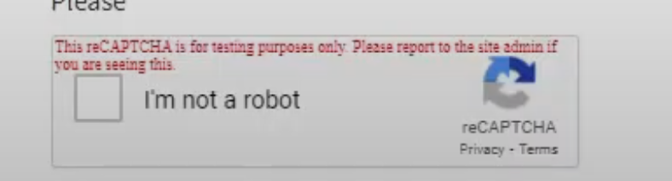

Sol:

1. Go to typoscript and select constant editor and category (plugin.recaptcha(8))

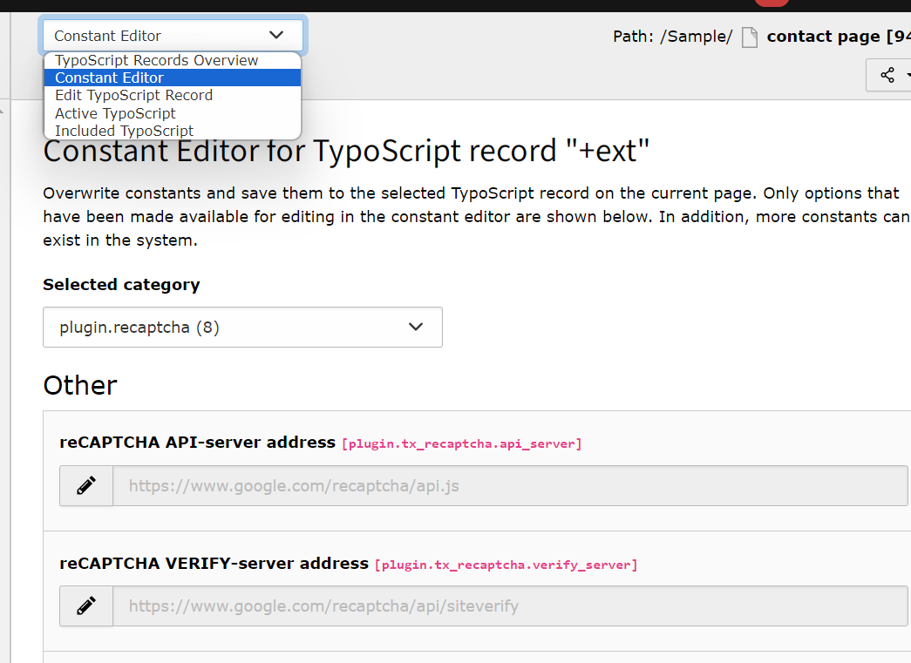

5)Create an account on google recaptcha website and enter the domain name.Here we chose V3

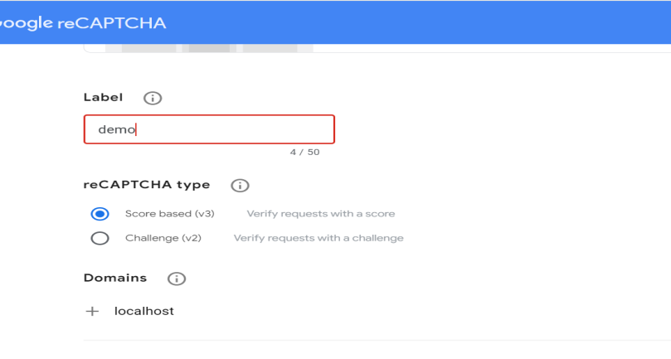

After submitting you will get site key and secret key.

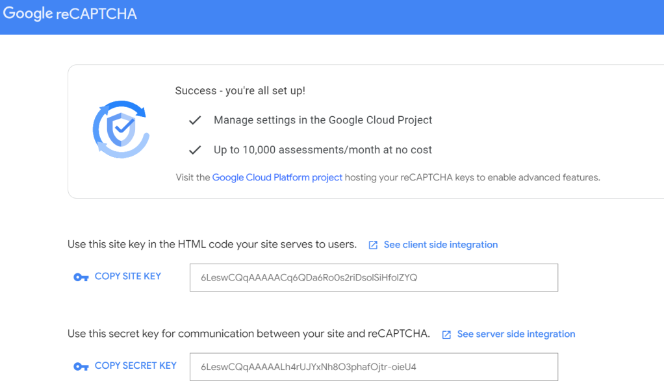

Paste the site key in public key and secret key in private key and save it.

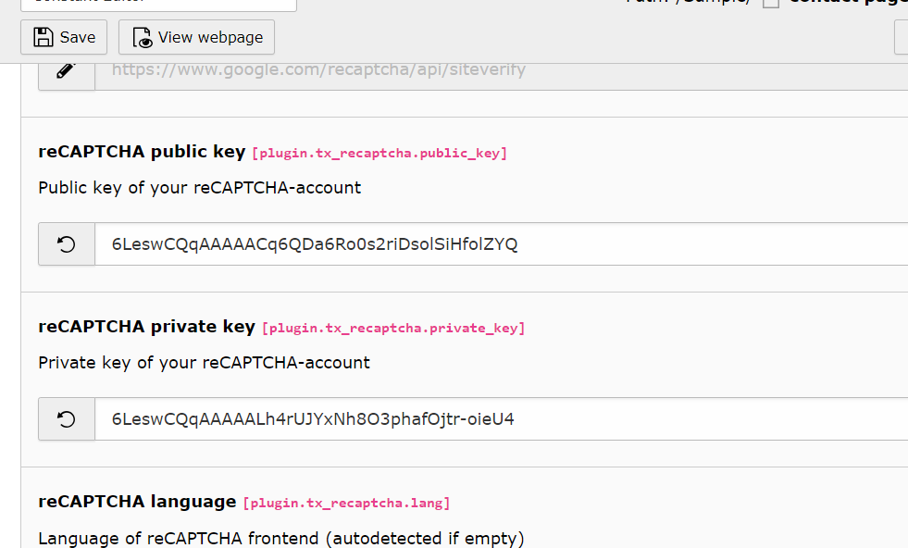

6)Save and view the page in frontend.

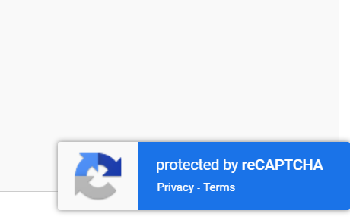

Internal configuration of the recaptcha.

To generate the token and it internally processes it and give accurate result. Give the version number and paste the site key and secret key.

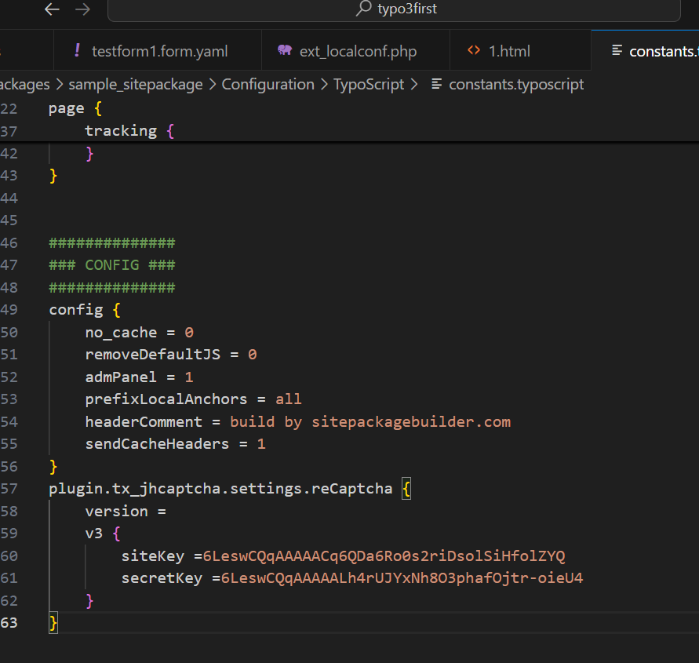

Once you inspect you will get the token generated(recaptcaha is working correctly).

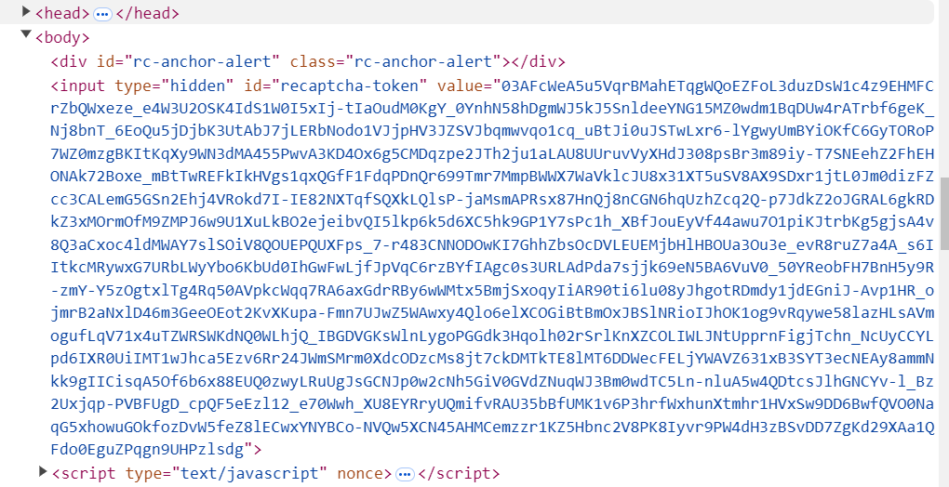

Cookies

Link

* <https://extensions.typo3.org/extension/dp_cookieconsent>

1. Install the extension. Inside the composer file.

composer req dirkpersky/typo3-dp_cookieconsent

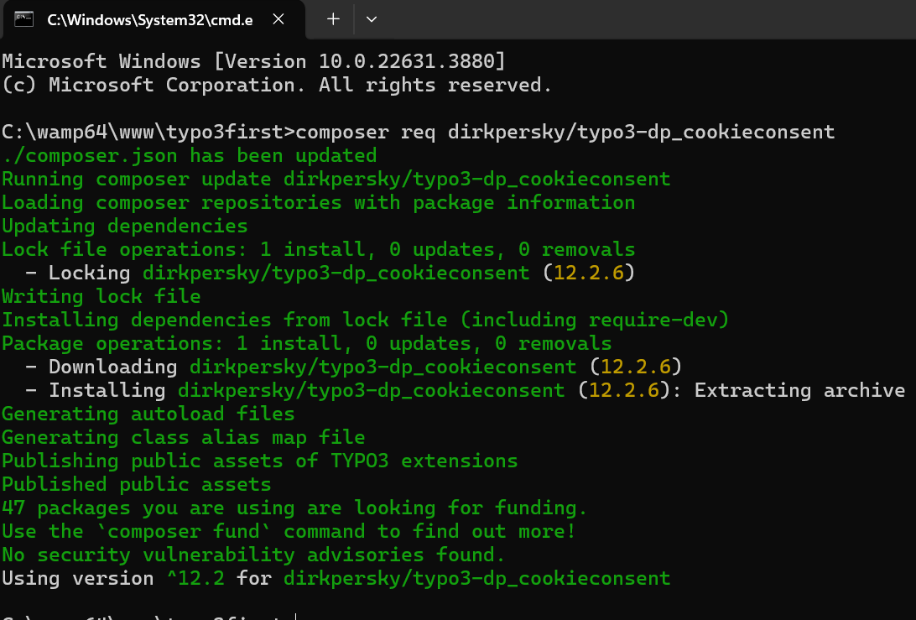

2)Add the cookie extention in the typoscript.

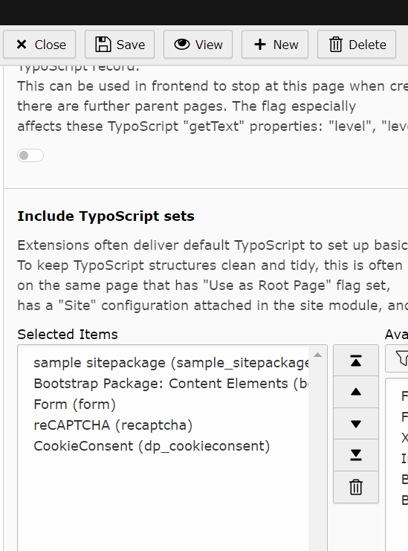

1. Go to page and create new element. Go to plugins and choose cookie listing.

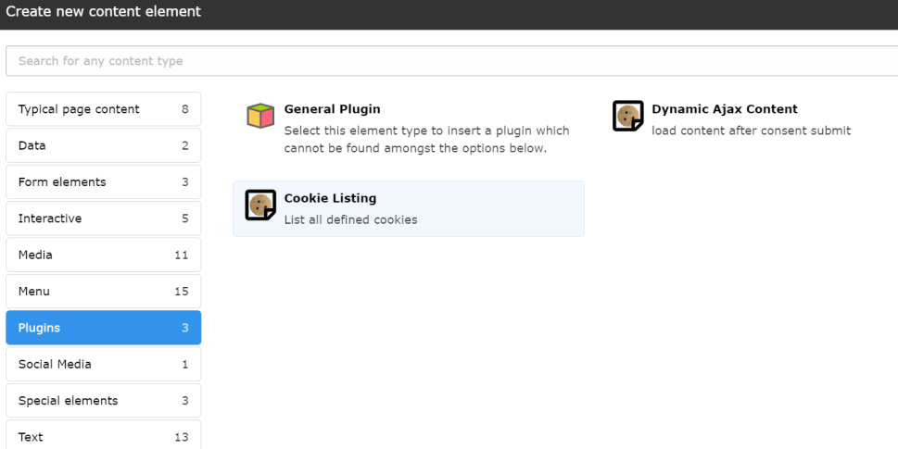

1. Add plugin cookie list and save it.

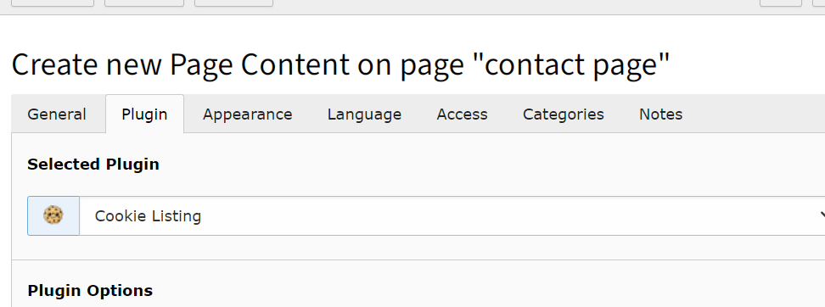

Error:

****503****

****Oops, an error occurred!****

Table 'typonew.tx_dpcookieconsent_domain_model_cookie' doesn't exist

More information regarding this error might be available [online](https://typo3.org/go/exception/CMS/1472074485).

Sol:

1. Must create index and table.

Go to maintenance and analyze data structure and click on apply selected changes.

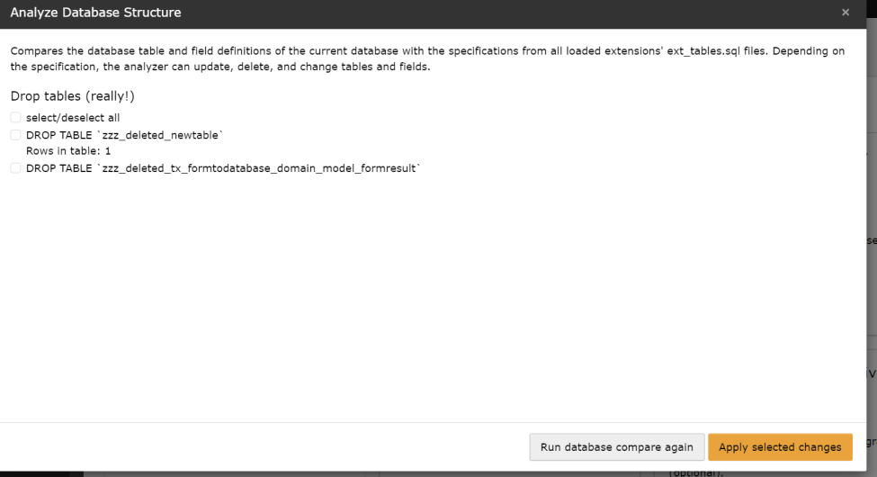

1. Flush cache and view.

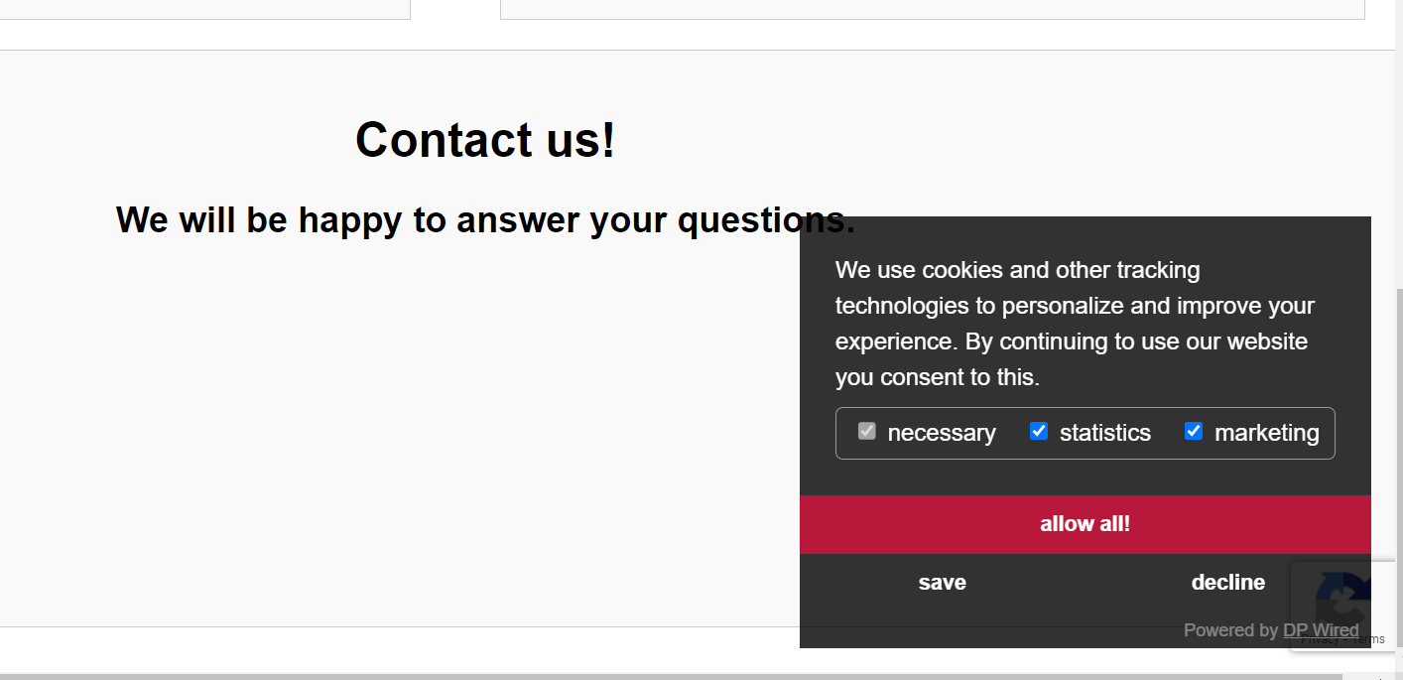

Background

1. Go typoscript and edit typoscript record.

2)Add the css bootstrap package.

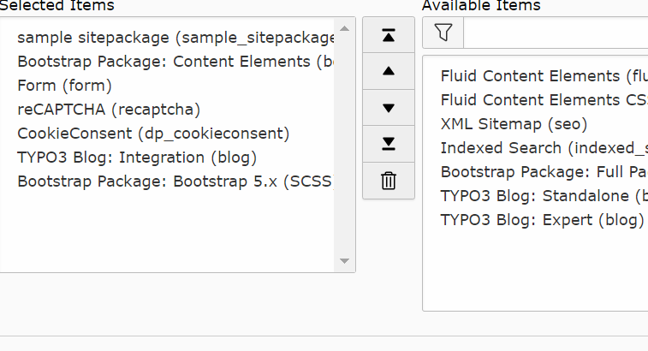

Sliders

1. Create new content. Under interactive elements choose carousel.

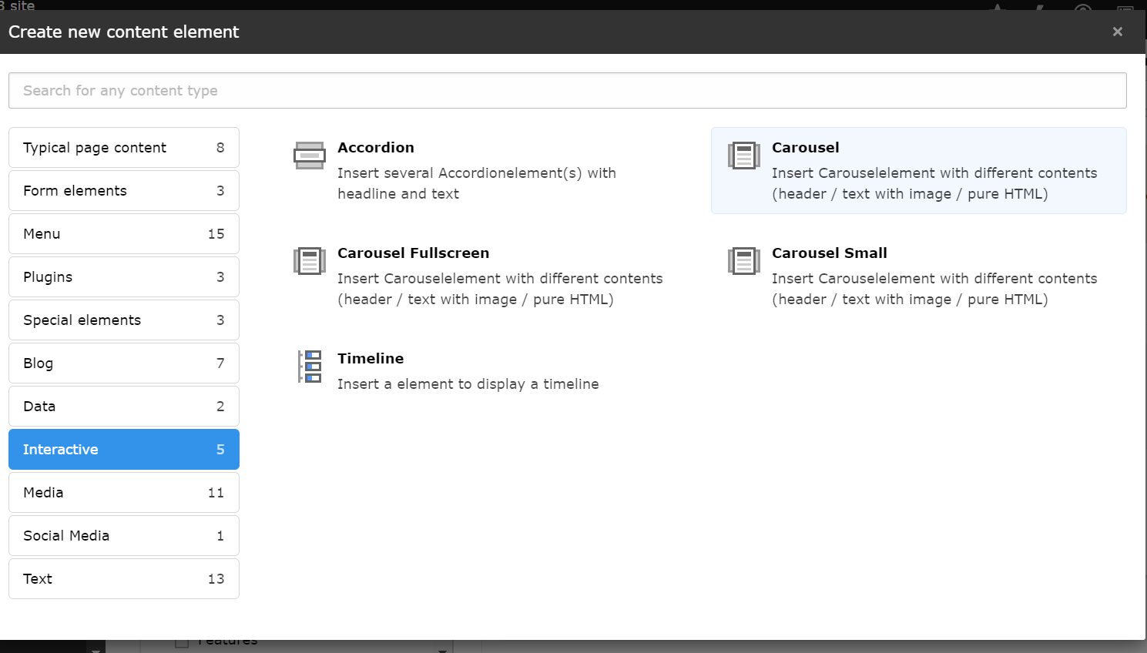

2)Add multiple items.

Create new to add next slide.

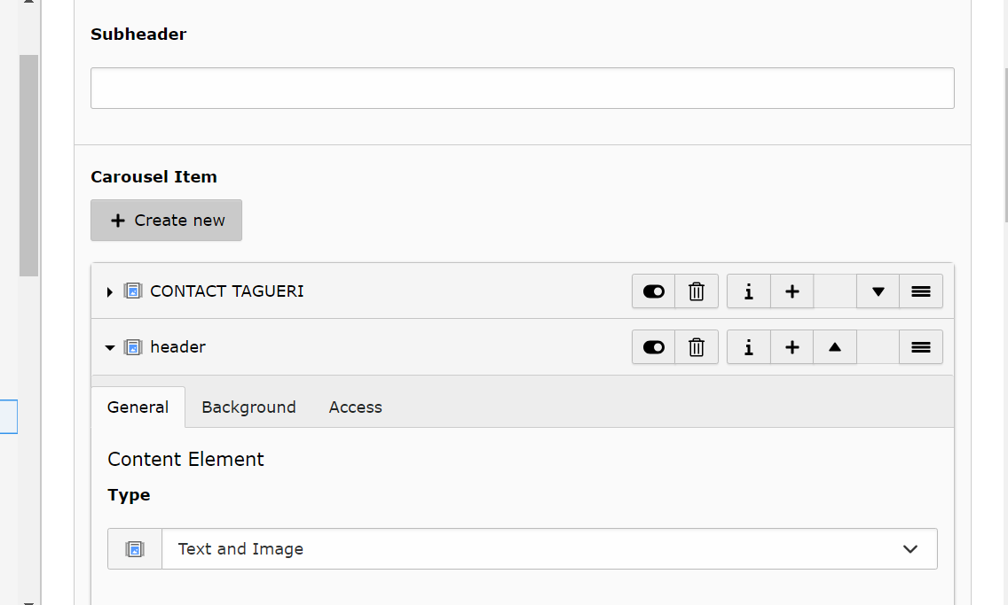

1. Save and view.



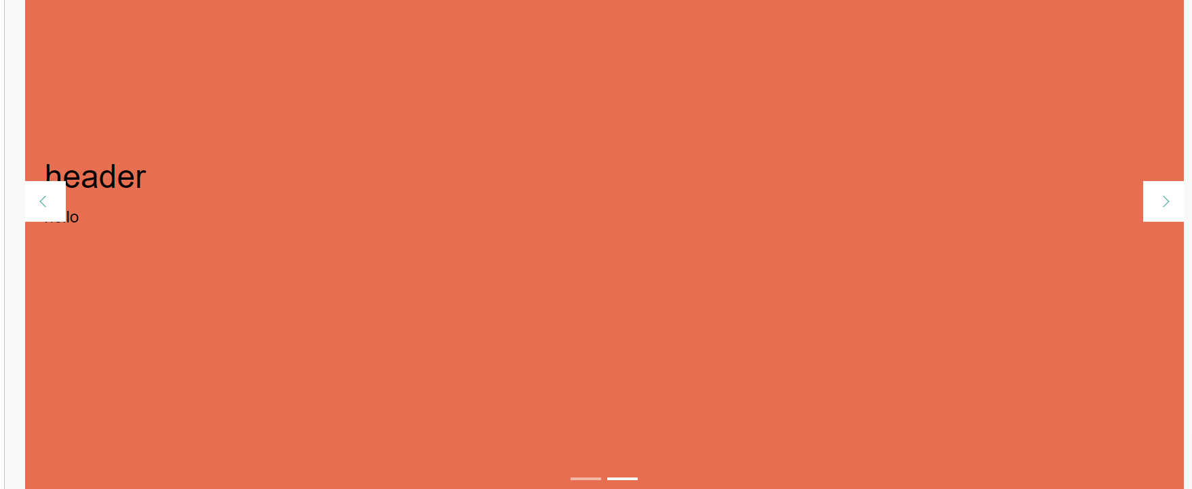

Blog

1. Install the extension.

composer require t3g/blog

error: the version available is 1.0 which dosent support our existing typo3 version.

So the extension isn’t being reflected in the backend typo3.

Sol: Must modify the version of the existing extention.(caution: must be done carefully else will collapse the entire website. Recommended to do in local site)

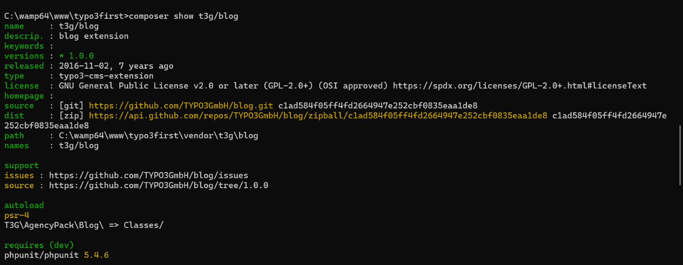

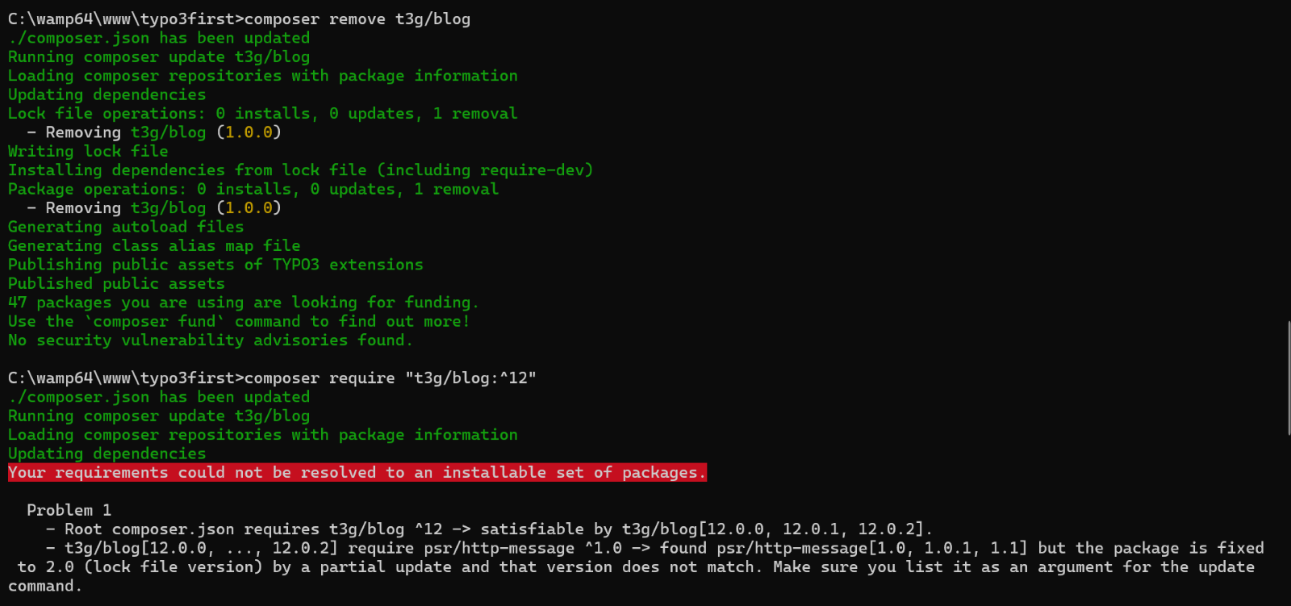

The existing is 1.0 but we require 2.0 which is dependent on psr/http-message so must update that.

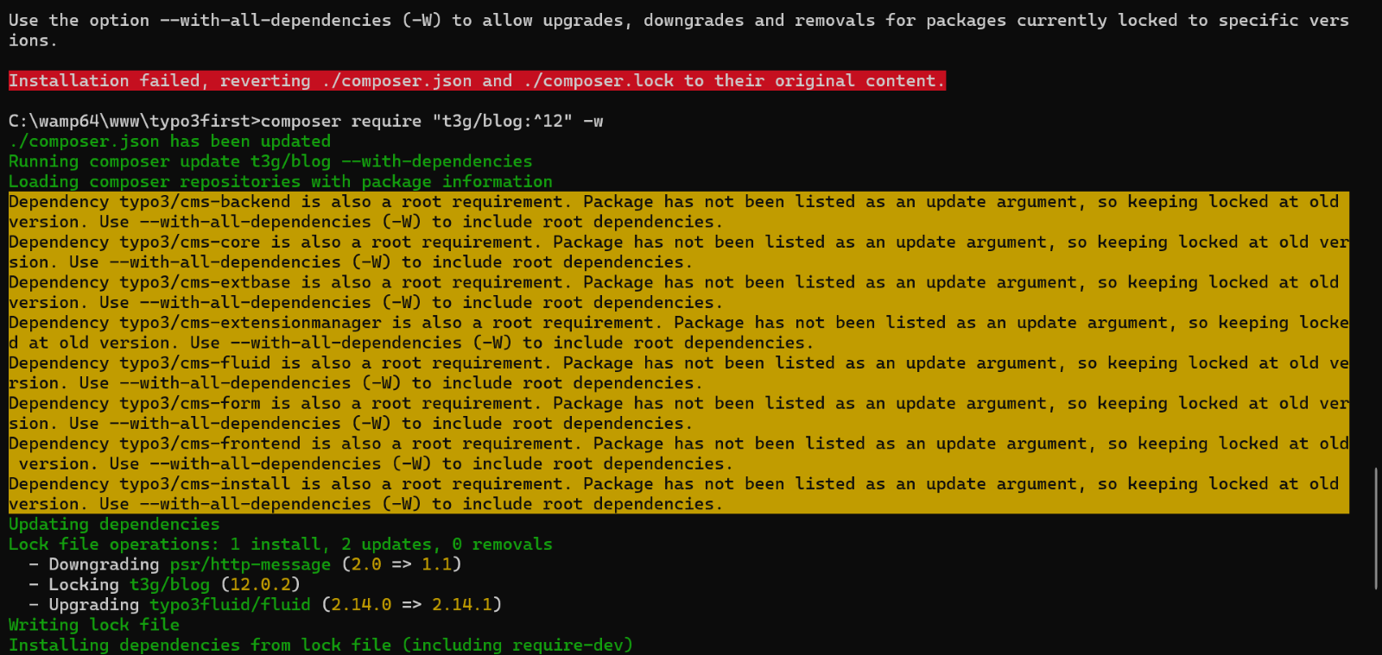

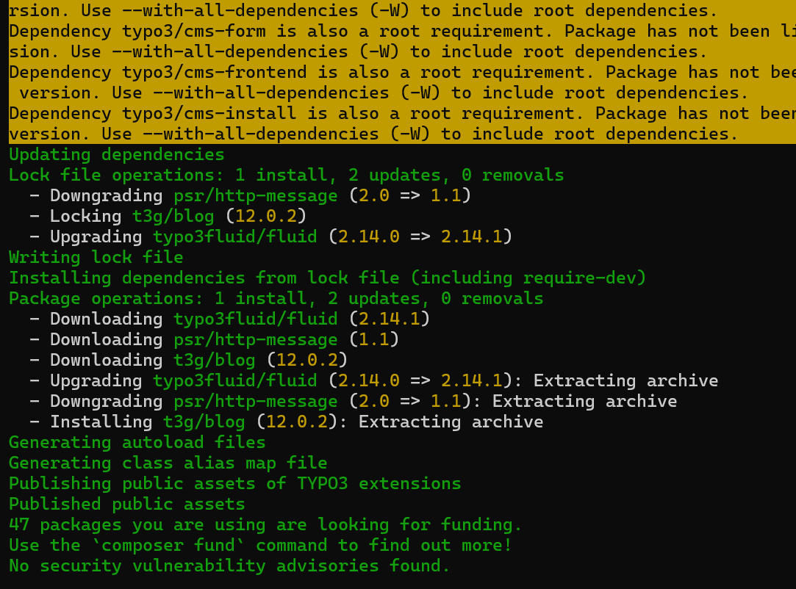

Now the extension is visible in the backend.

Link

* <https://docs.typo3.org/p/t3g/blog/main/en-us/Setup/Wizard/Index.html>

can do manual set up wizard set up.

To create a blog page

1. Go to blog and create a new blog.

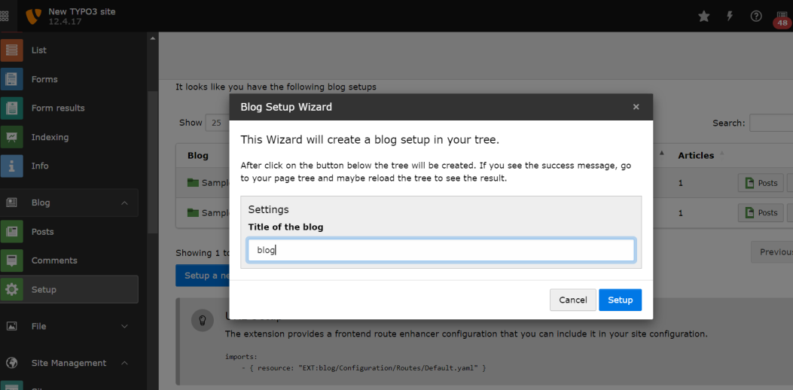

Error:

An exception occurred while executing a query: Unknown column 'publish_date' in 'field list'

Sol :

Go to analyze data structure and apply the changes.Automatically it will be reflected in page.

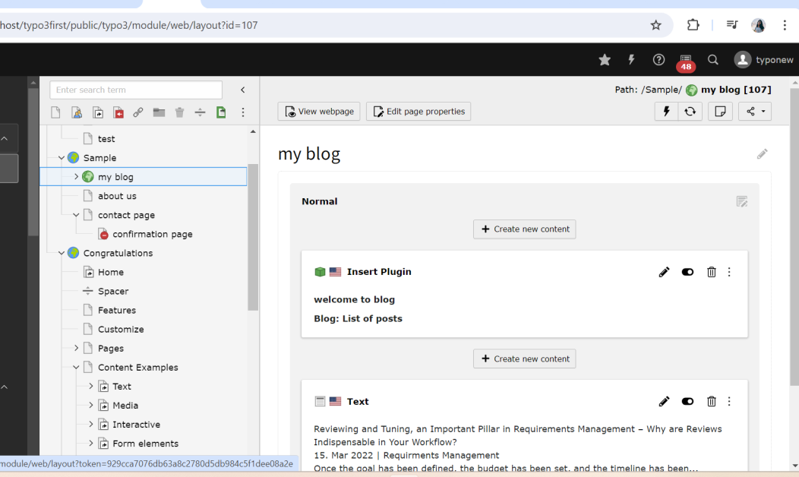

1. To create multiple pages click on the root page. And create multiple pages give the title names.(option1)

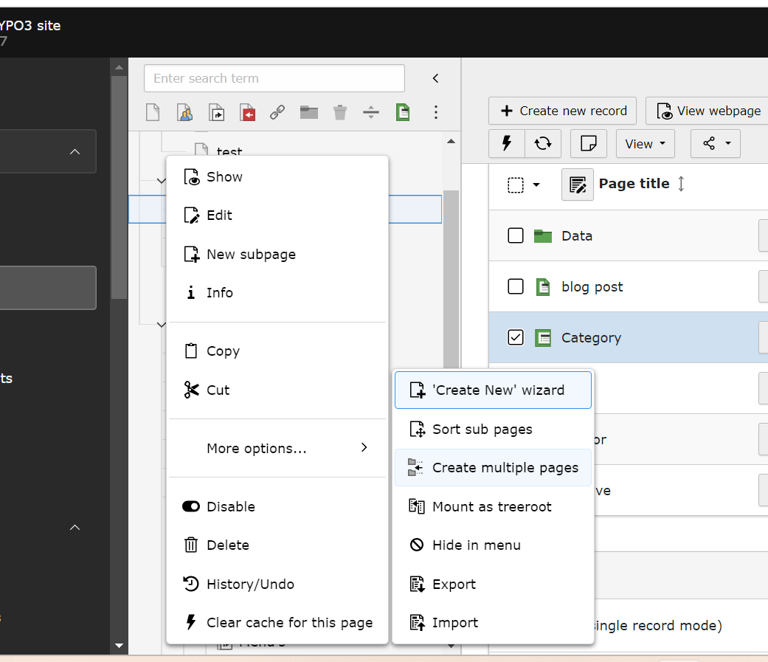

Give the page titles here.

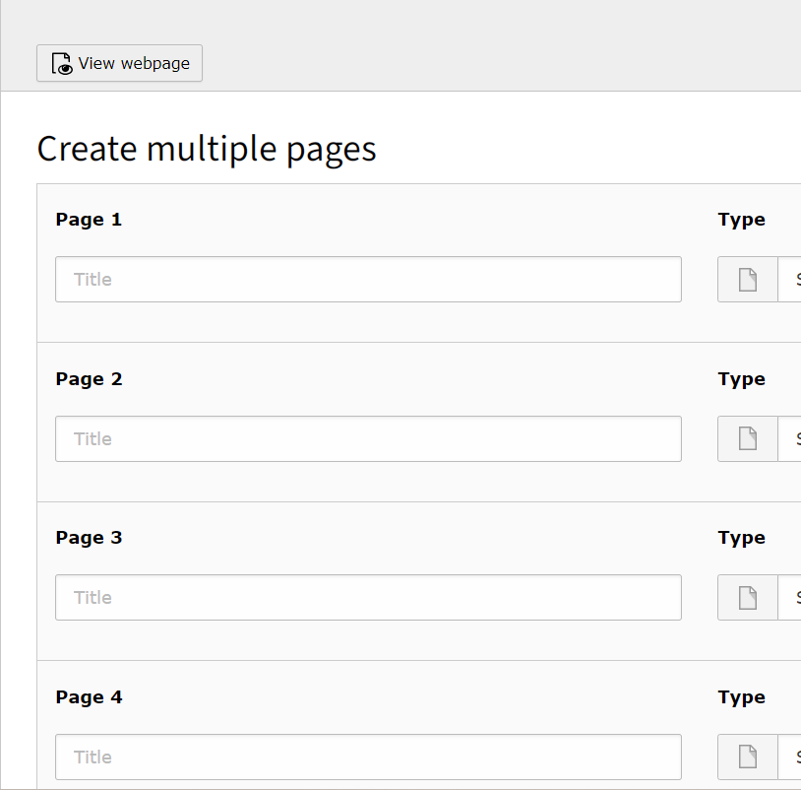

Or option 2)

Go to list and click on new record.

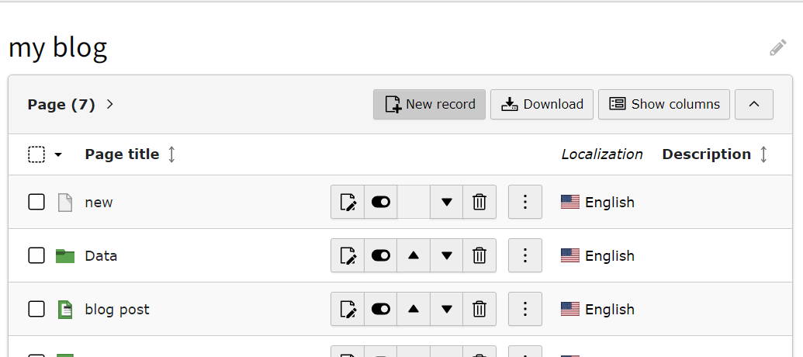

Click on the location where you want to add the new one.

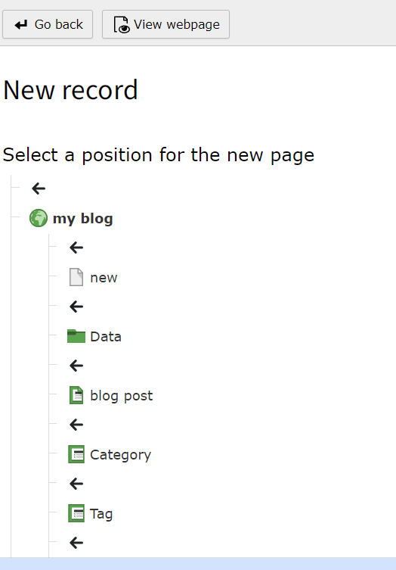

Output: save and see

Can add content in the blog

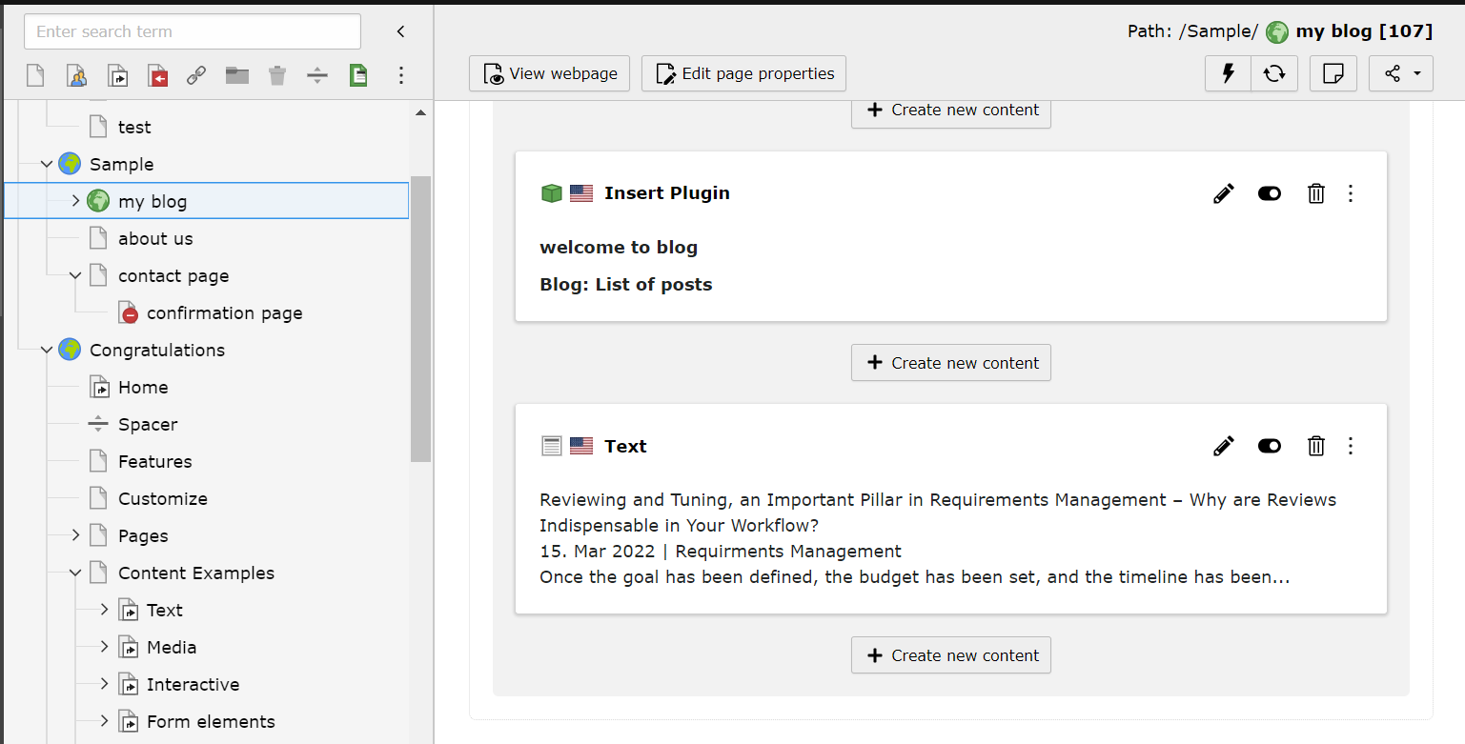

Output:

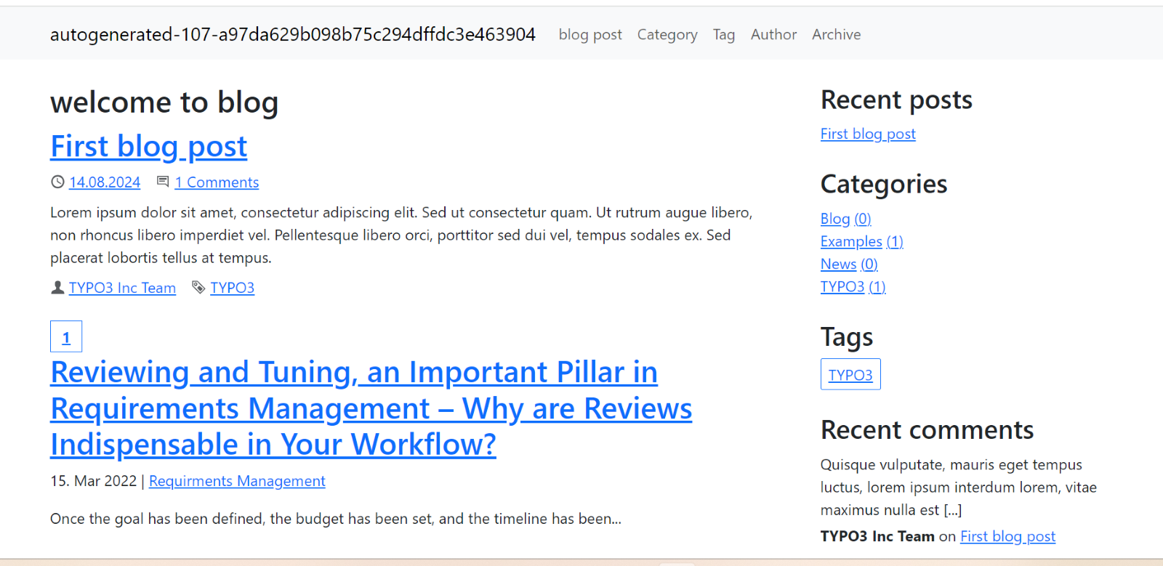

To create new blog post

1. Go to data and the go to list and click on new record(pages)

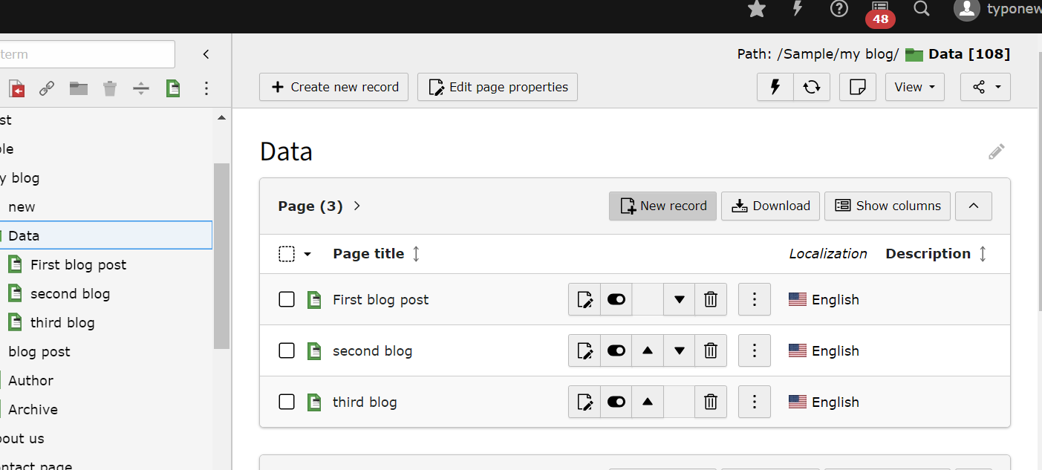

1. Save it.

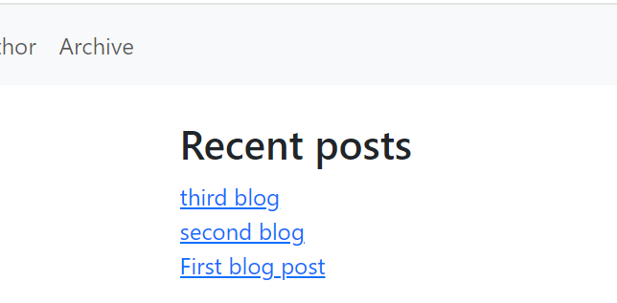

To add content in blog

1. Go to page module and click on the blog in which you want to add conent.

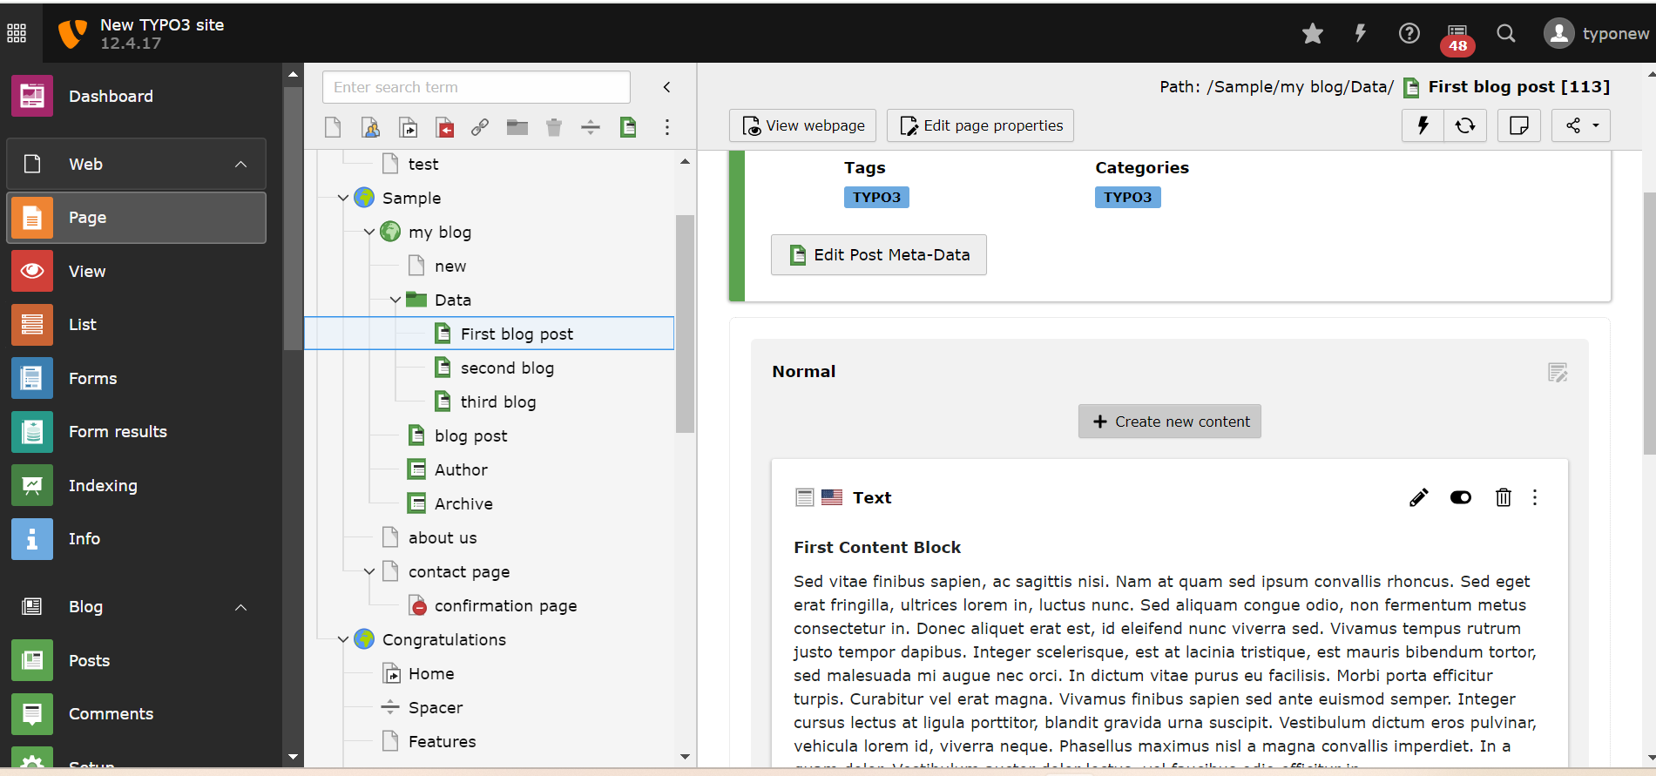

2)save and see the content.

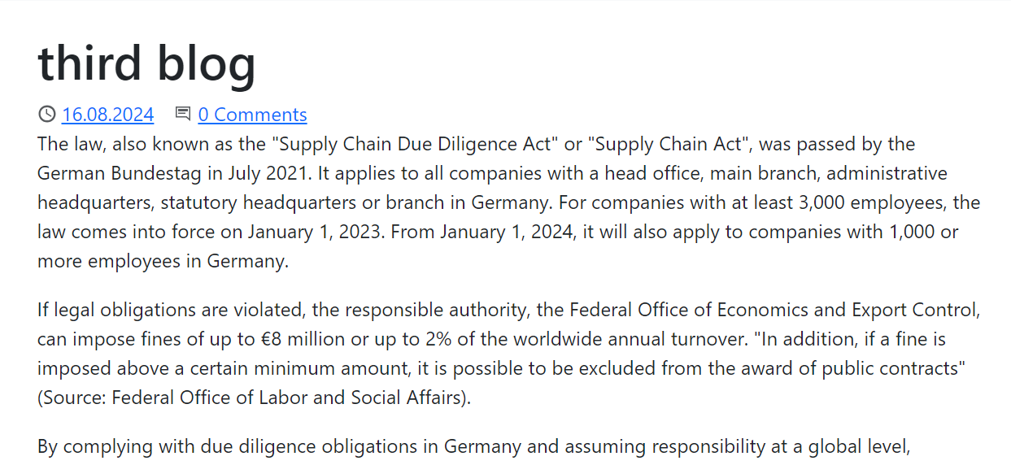

Cards with images inside blog

1. Go to your blog post and select menu(card group).

Add the desired image.

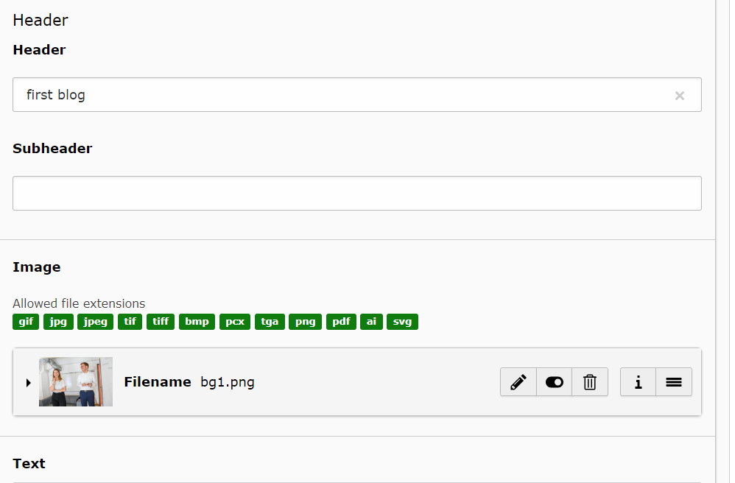

1. Add the records here and the url link of the created blog.

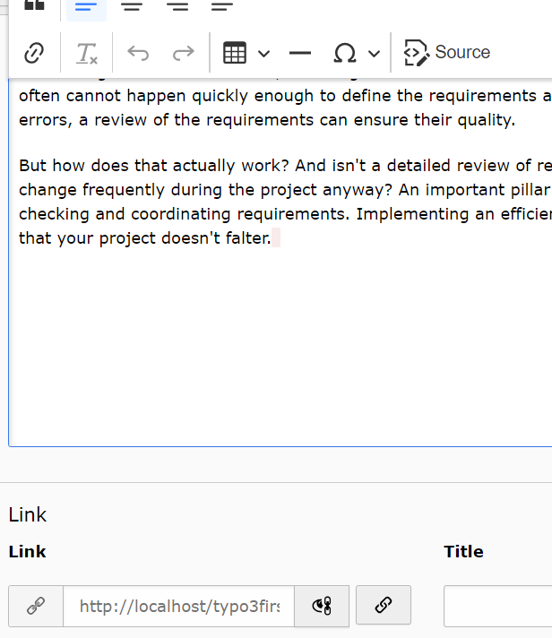

1. Go to options and choose the number of columns needed.

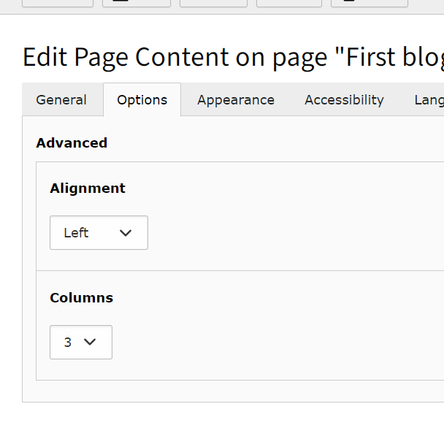

1. Click on your blog and go to typoscript.( root blog page)

Add bootstrap contents and css package.

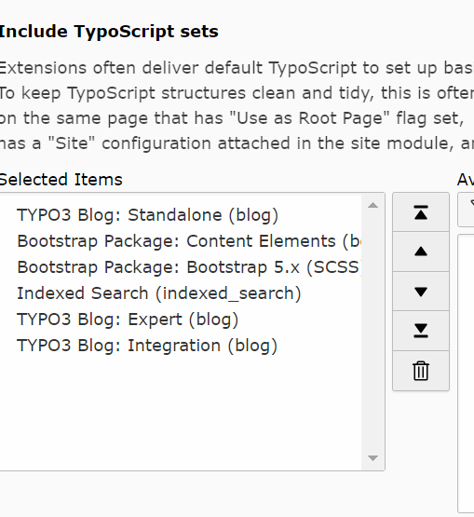

3) save it.

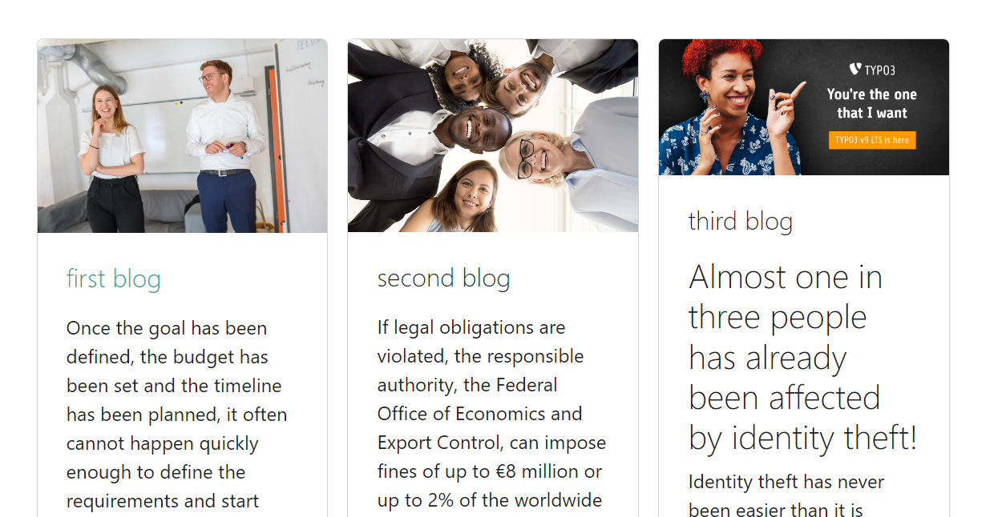

Error : coming under the first blog but cant add to data as it is a folder.

Sol:

1)change the data folder to “standard”.

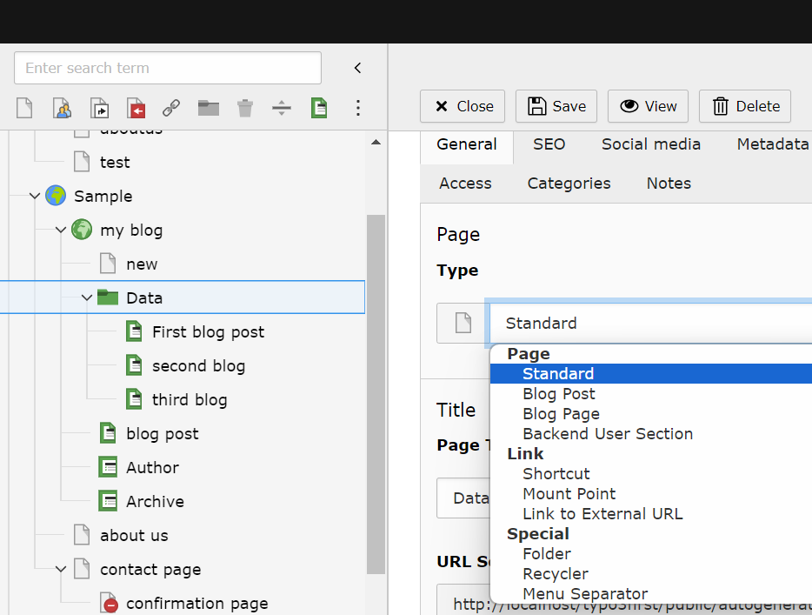

1. Add the card elements and content here.
2. Save it.

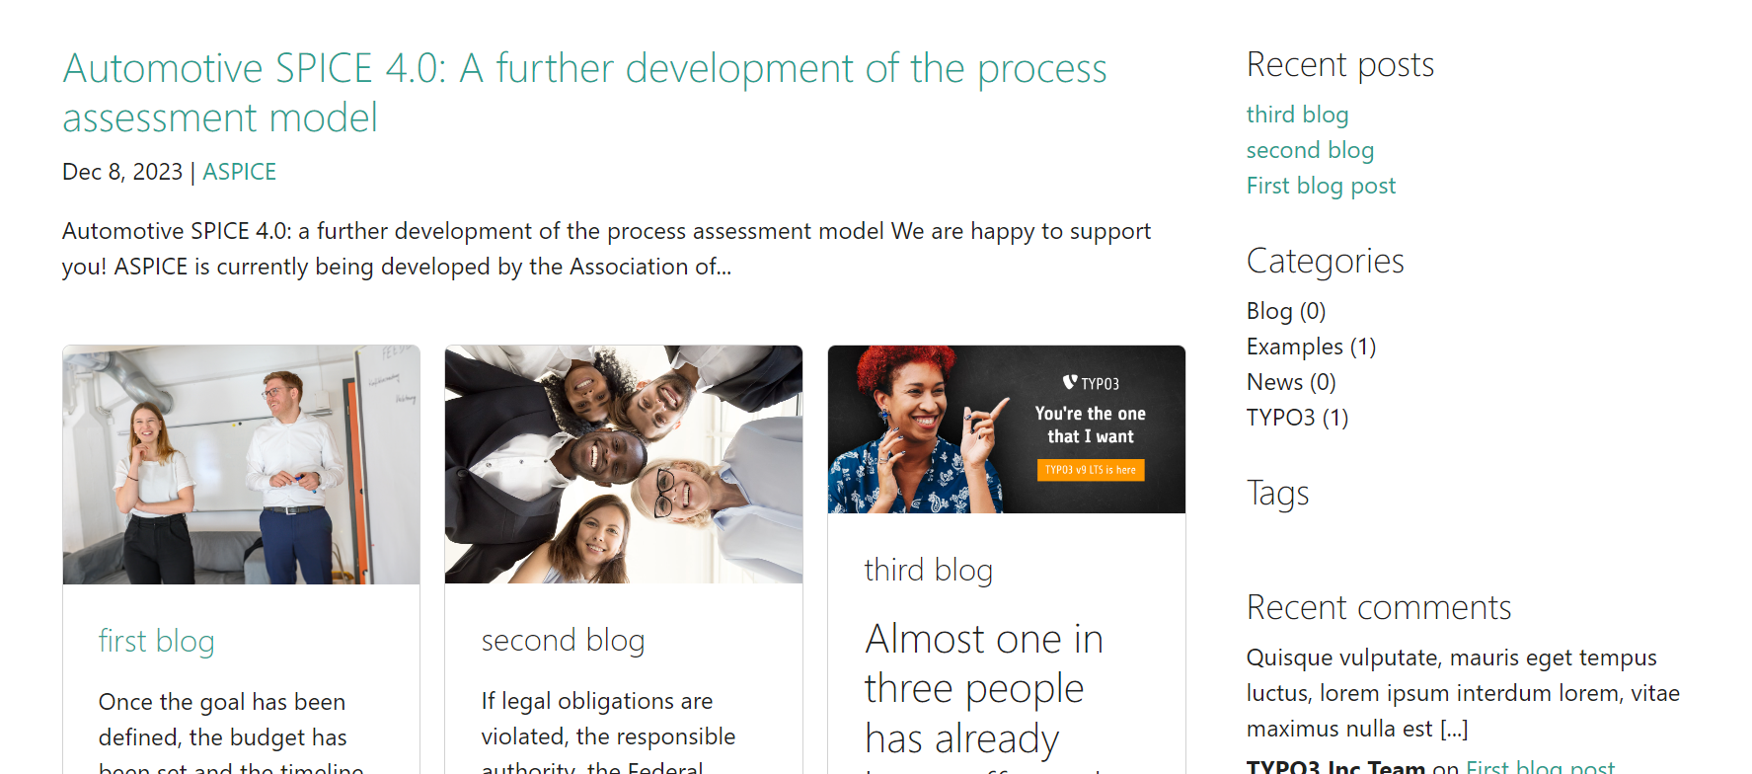

Problem: to remove the content on right as this is the home page.

Sol:

1)go to in the backend

Vendor/t3g/blog/resources/private/template/page/bloglist.html

And comment this side bar section only for this particular page.

This wiil rmeove side bar for the home page and will still be present in other blogs.

<!-- <aside class="blogcontainer-sidebar">

<f:render section="renderPlugin" arguments="{listType: 'blog_sidebar'}" />

</aside> -->

Output:

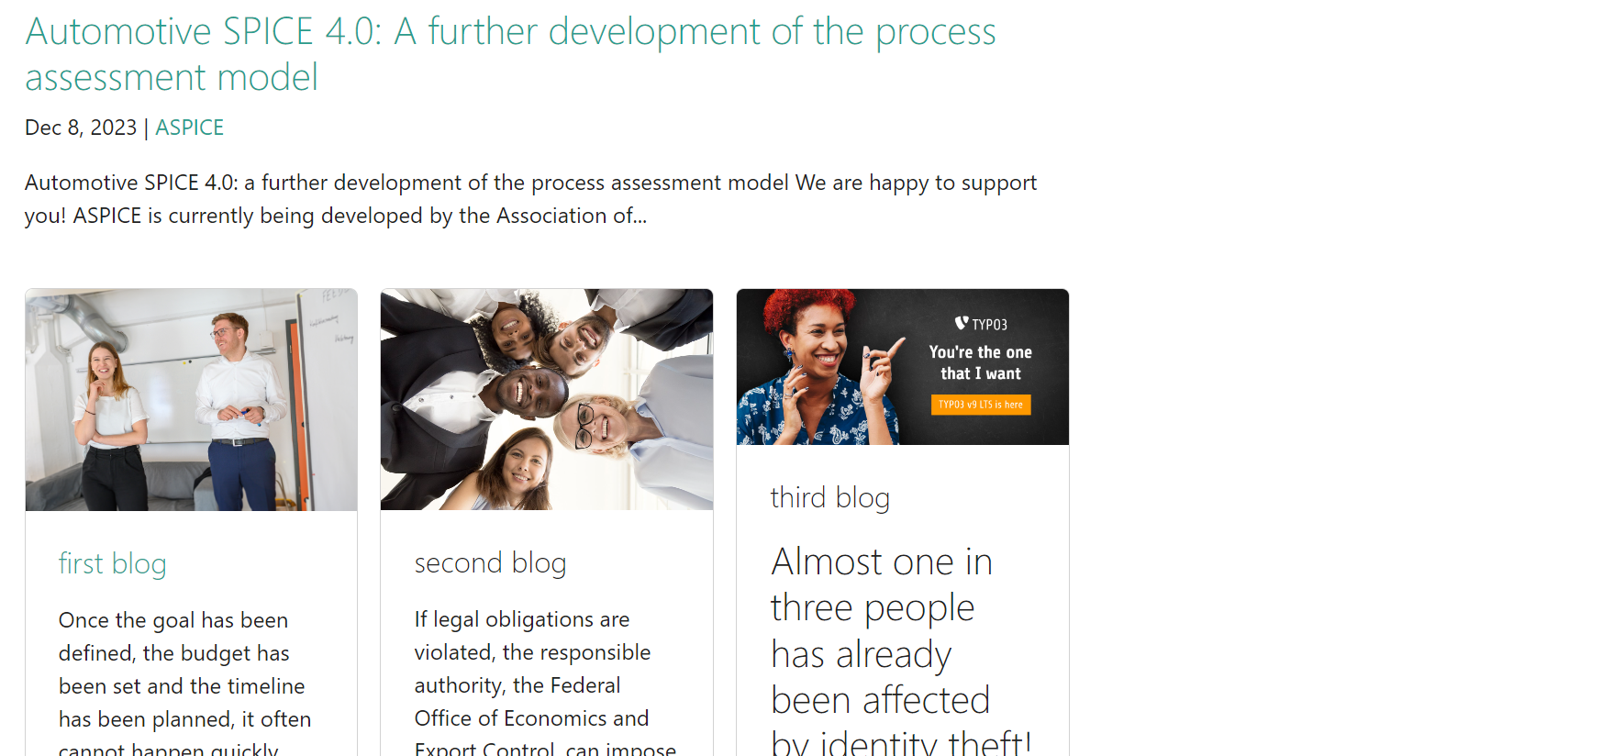

If you click on any blog.

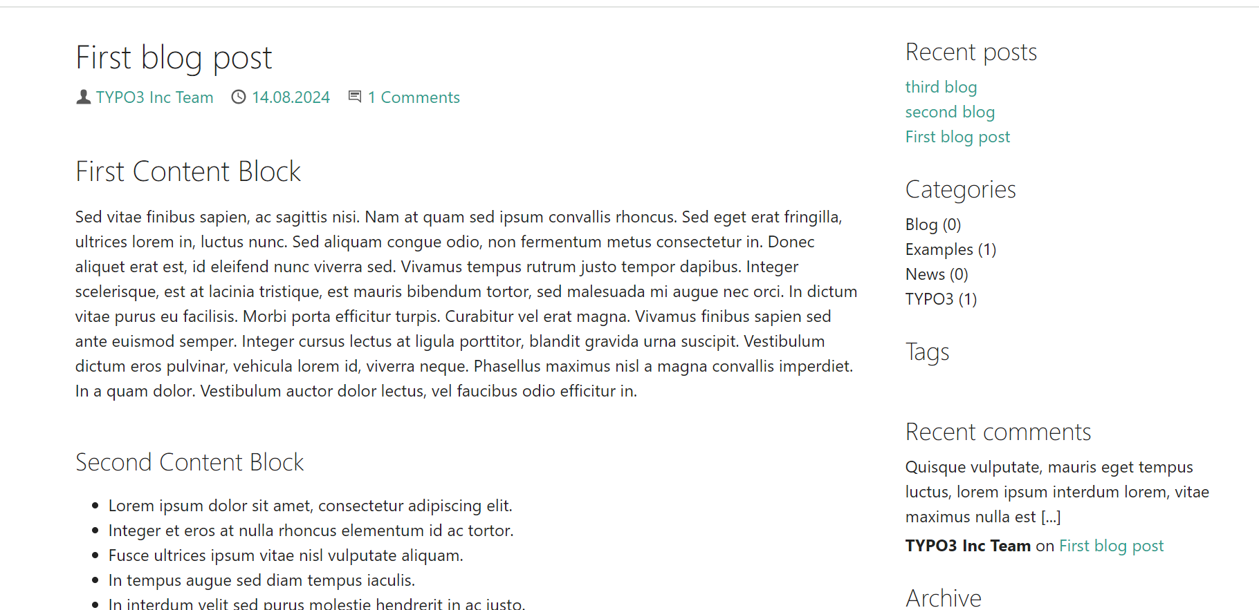

To install theme

1. Download the extention to get the desired theme in typo3 folder.

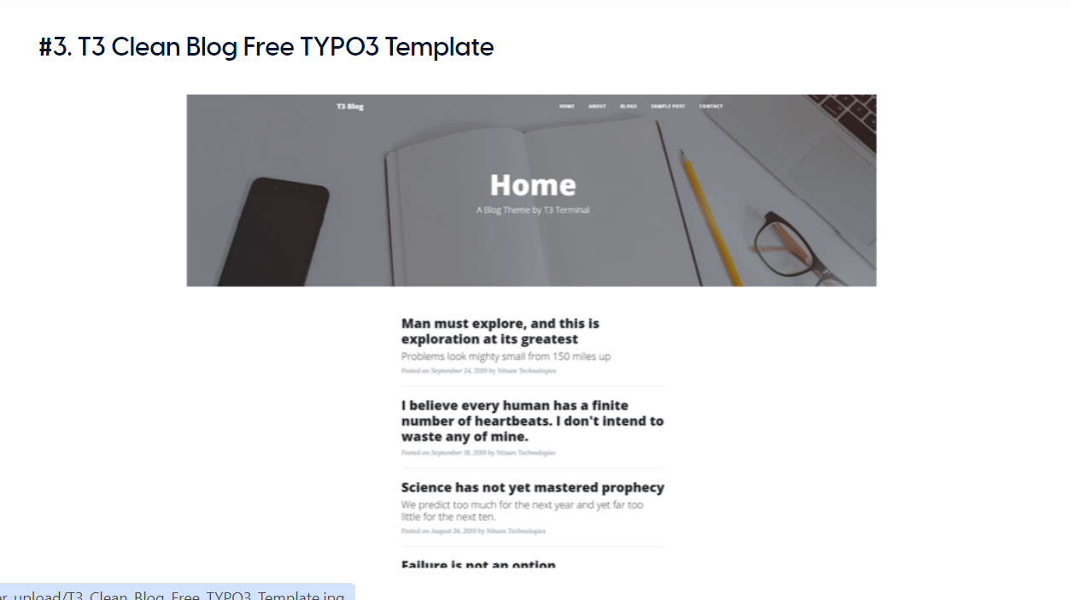

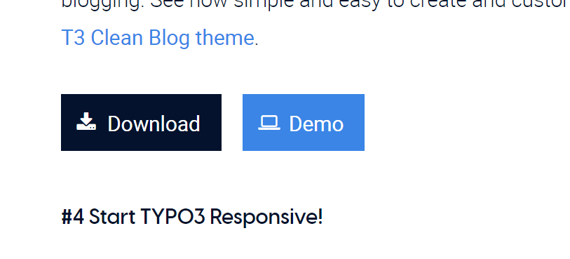

Download it.

2)composer req nitsan/ns-theme-cleanblog

Command to download in the composer.

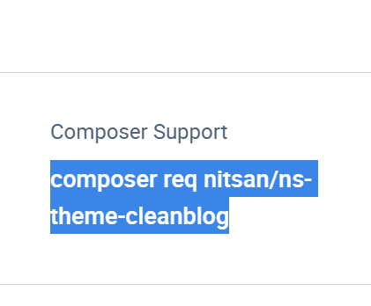

After the composer file is updated run this command in the command prompt.

vendor/bin/typo3 extension:setup

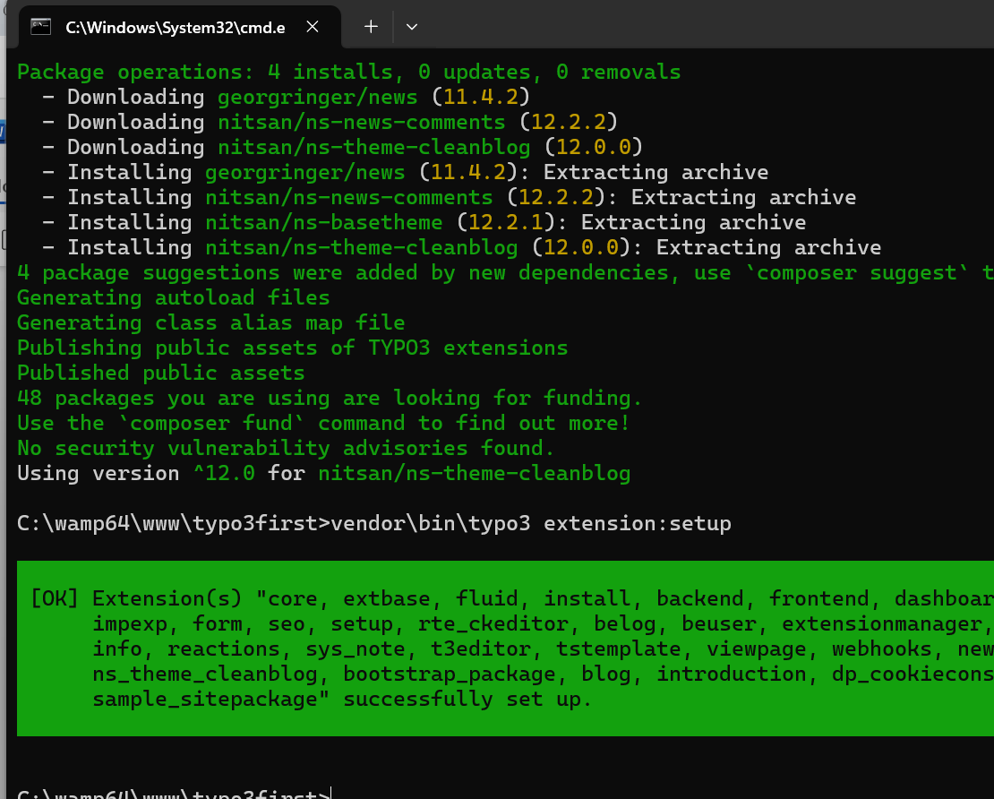

3) once the theme is installed themes module will be reflected.

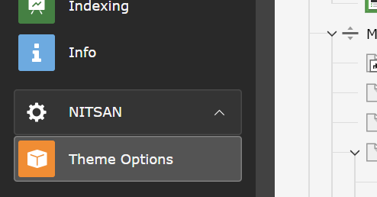

The downloaded theme.

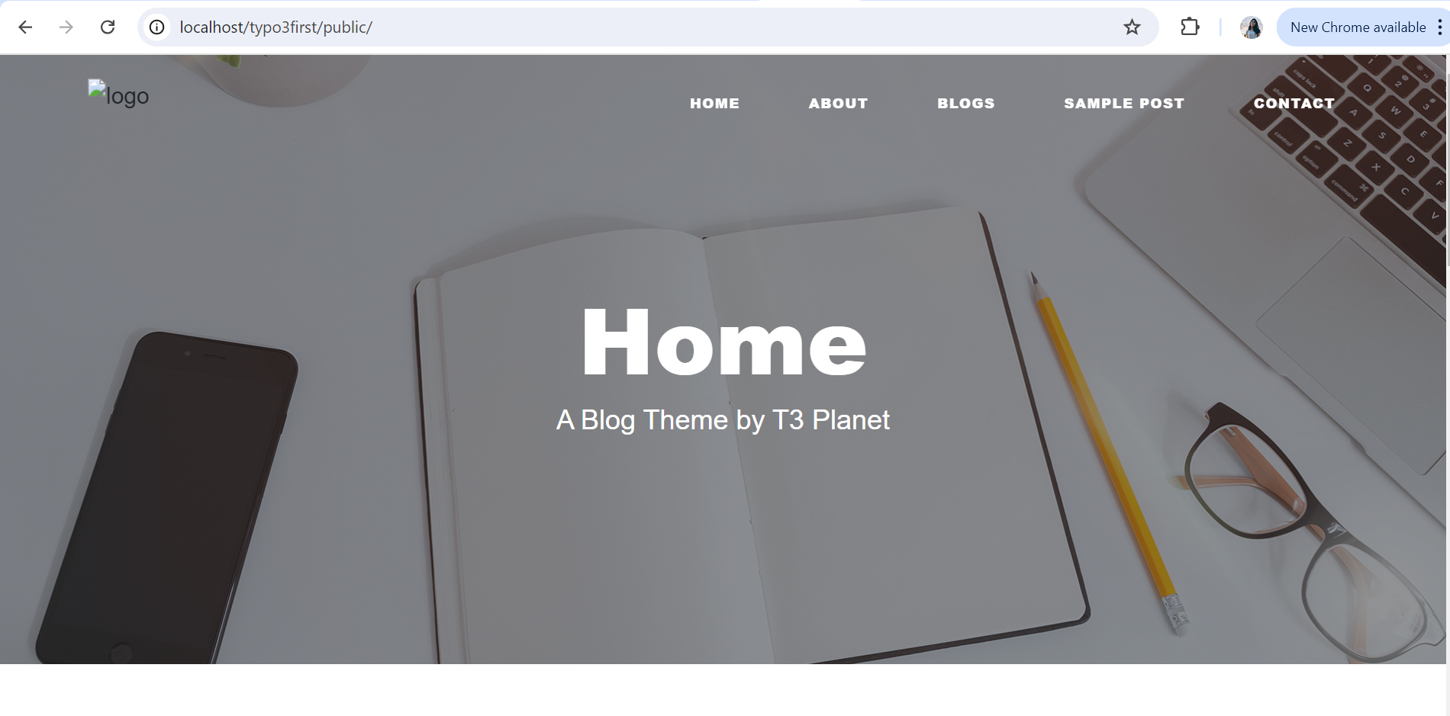

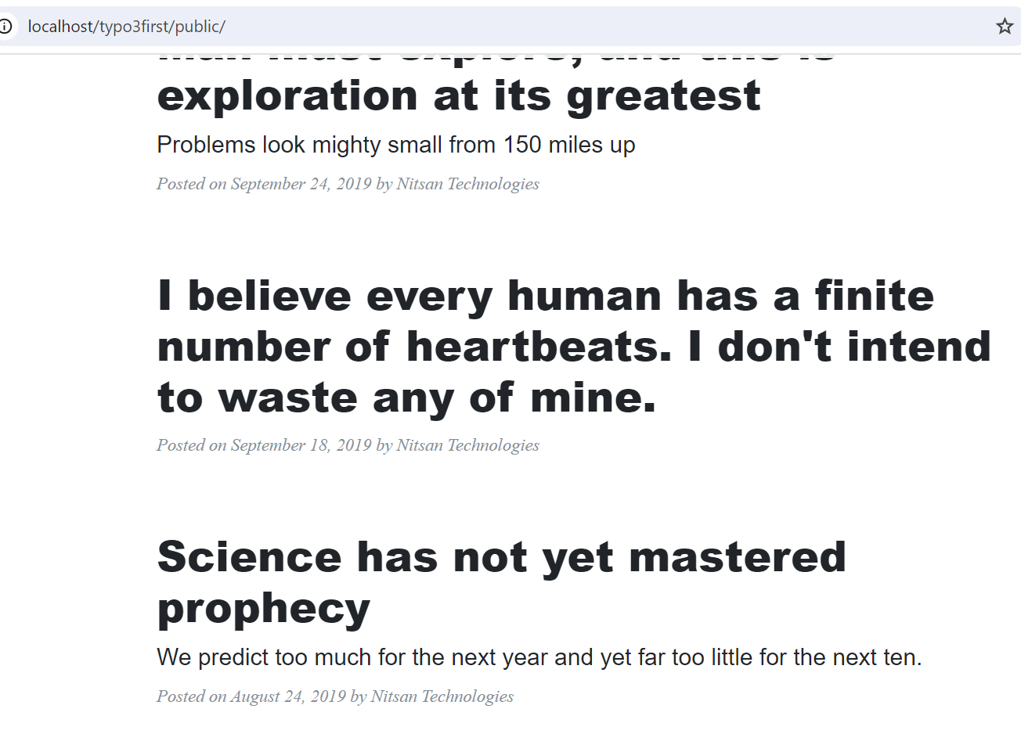

To add a blog in the theme

Link:

<https://t3planet.com/blog/free-typo3-template/>

<https://t3planet.com/t3-clean-blog-free-typo3-template>

1. Go to the page where you want to create the blog. And choose type blog post.

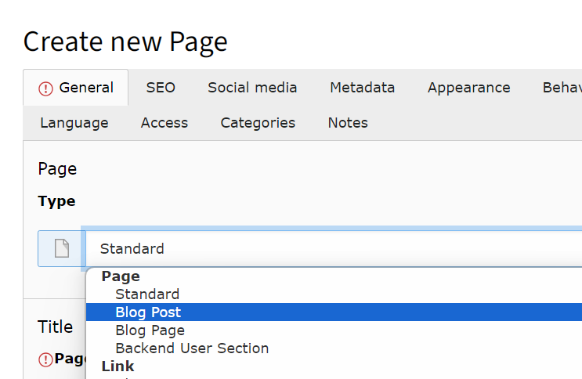

2)add the desired content to the blog.

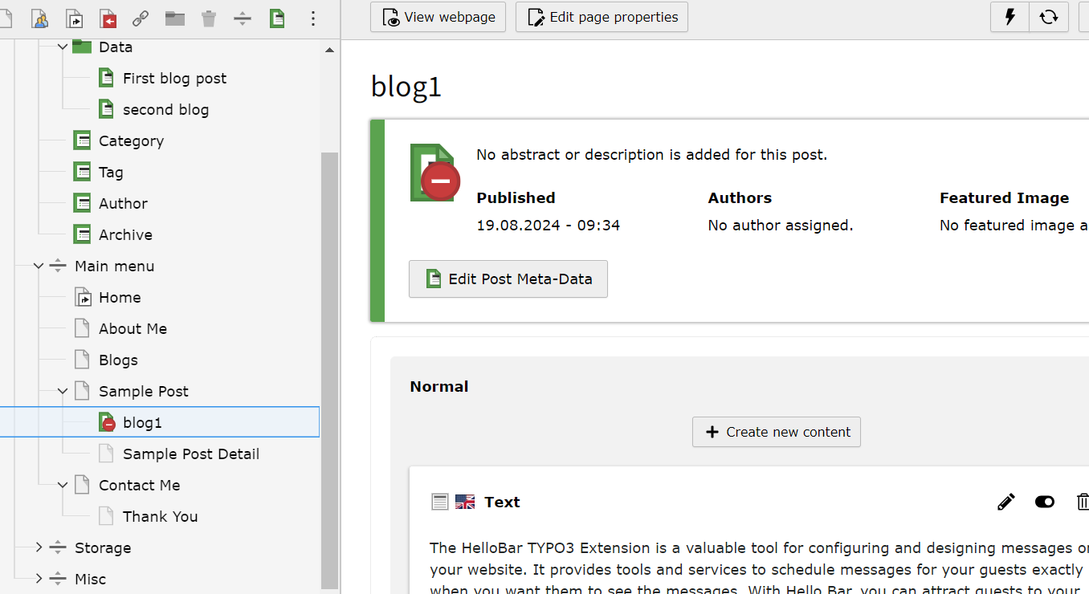

3) save and view it.

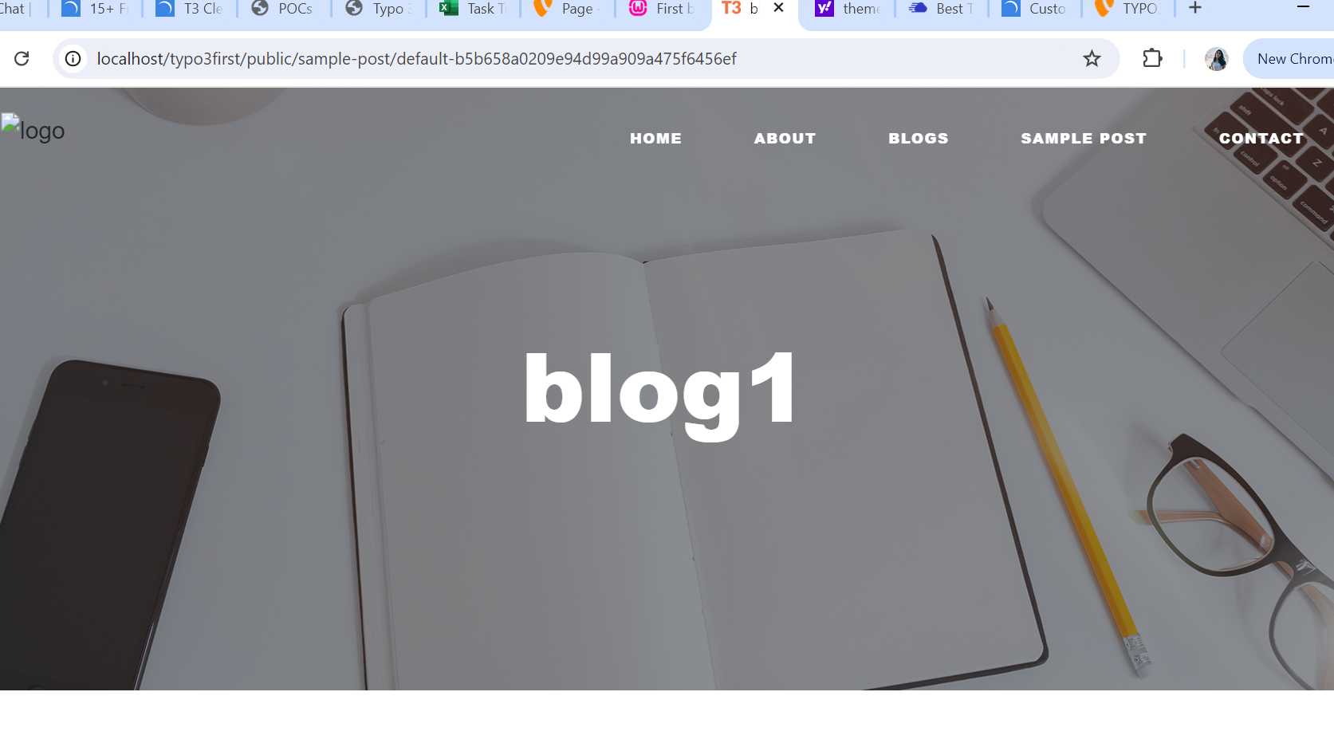

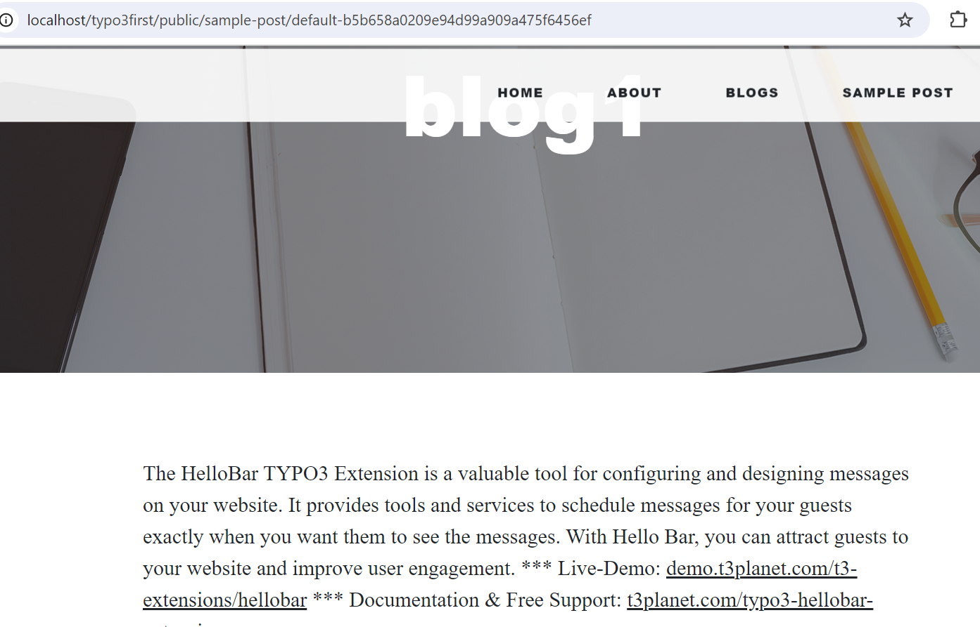

FAQ SECTION

* Link: https://extensions.typo3.org/extension/ot_faq

1. Download the extension.

composer req oliverthiele/ot-faq

1. Go to create new element and in plus ins choose faq.

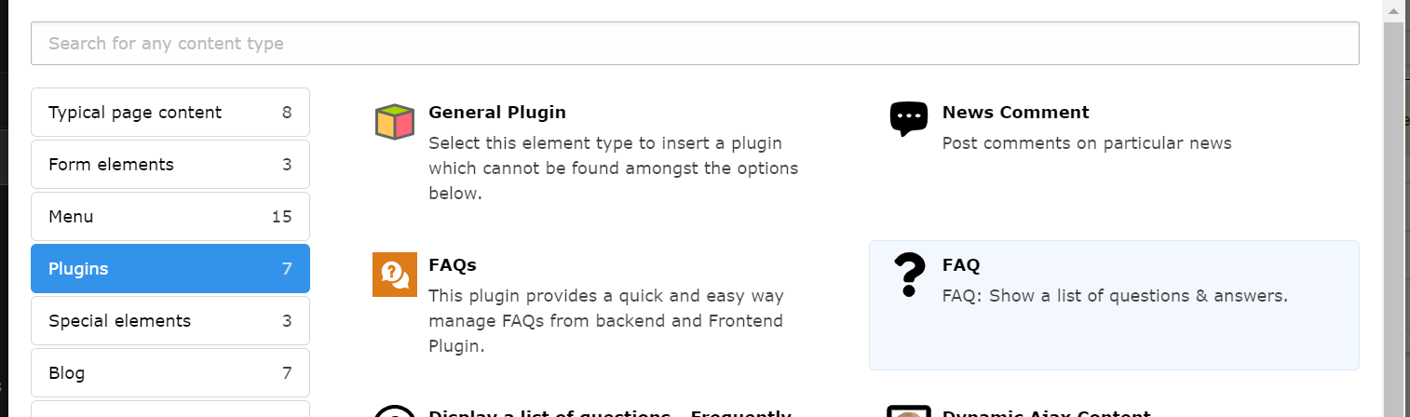

1. Go to typoscript and add the faq package

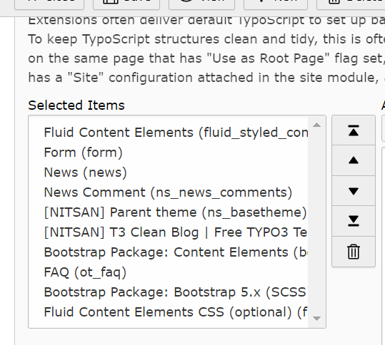

Error: questions weren't getting displayed inspite of adding in the backend.

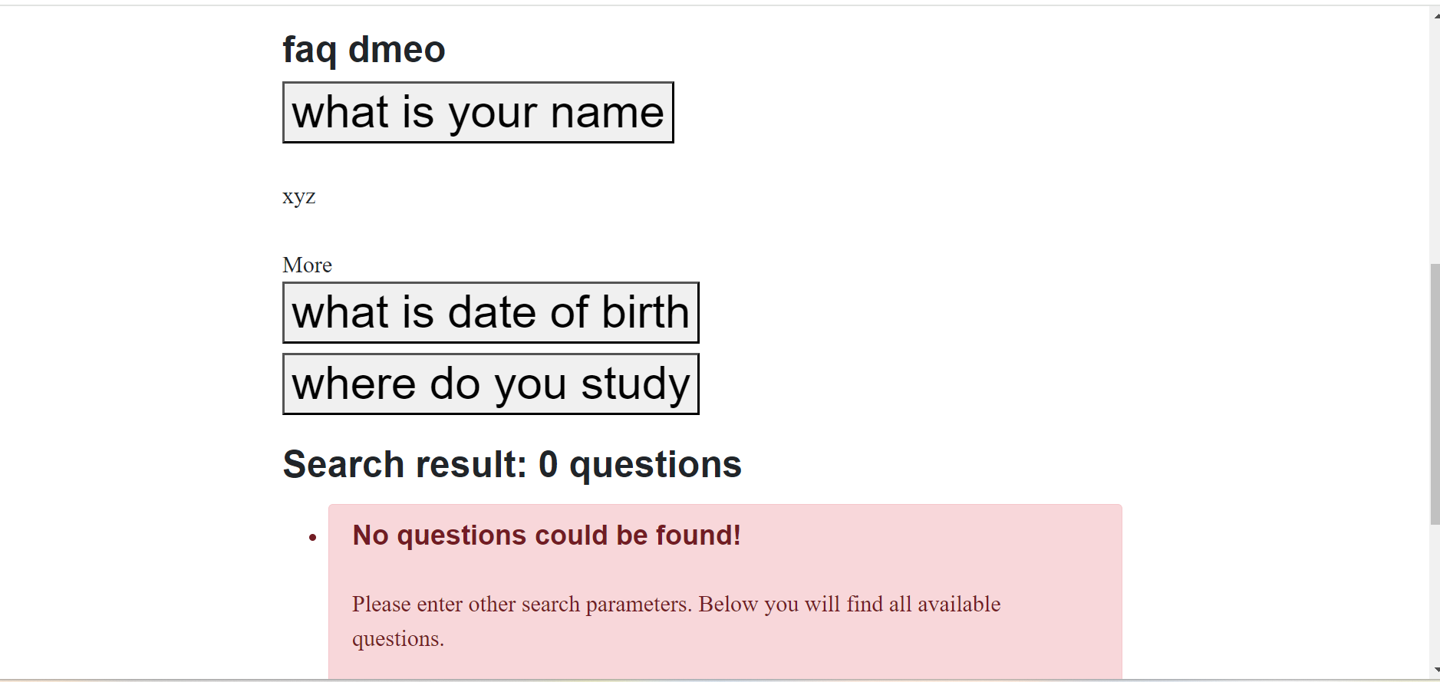

Solution:

Add the last 2 packages in the typoscript .



1. Go to list module and click on new record. (left top most)

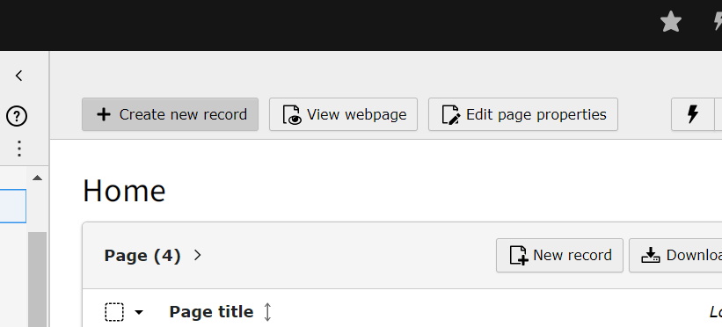

1. Click on FAQ

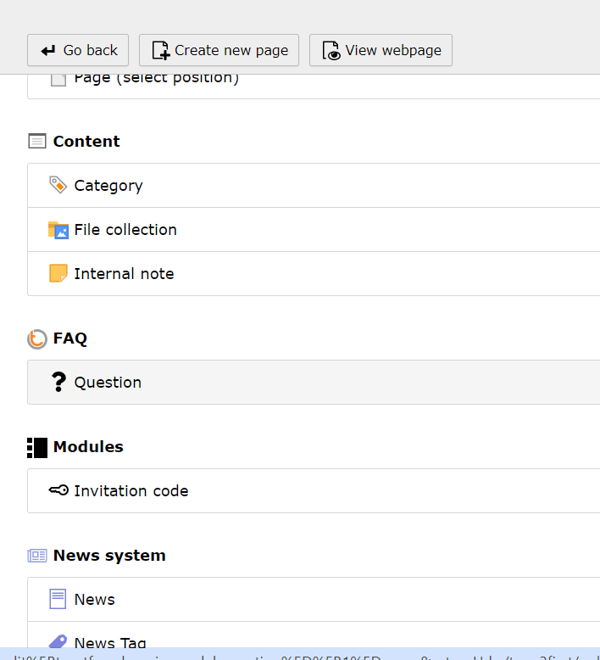

1. Write your desired question and answer.

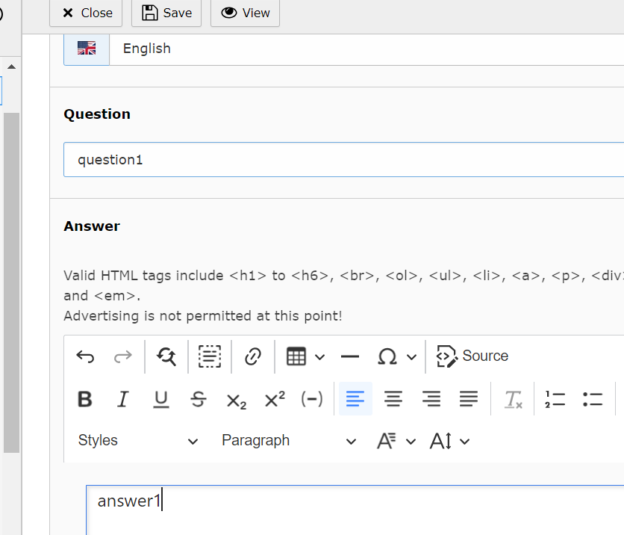

1. Save it and view it.

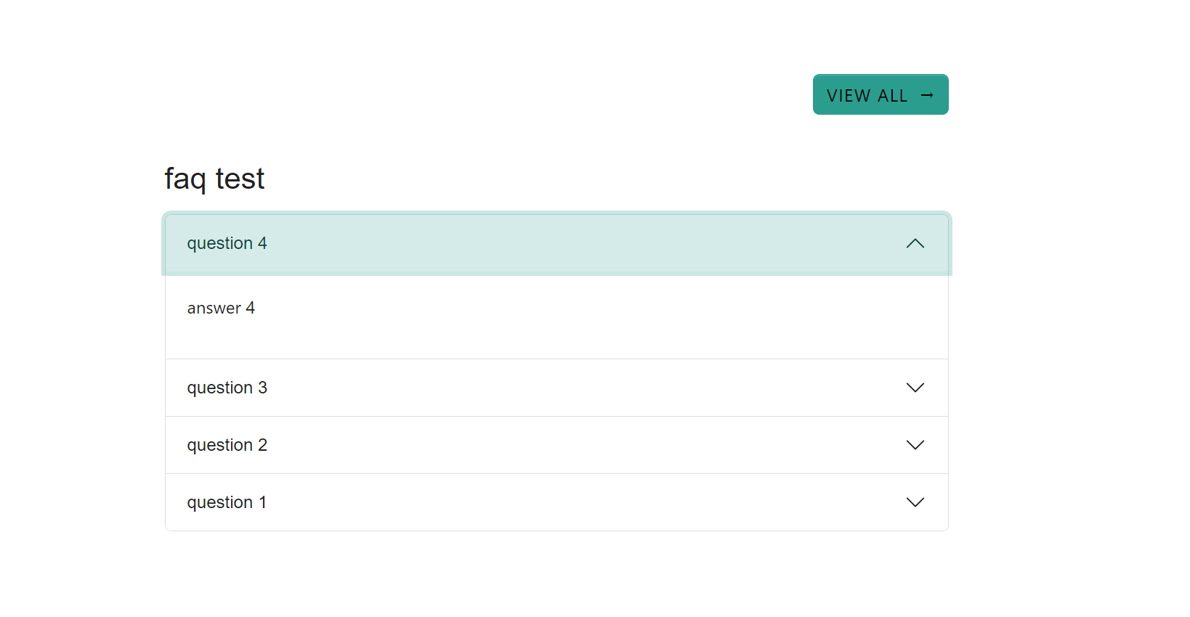

Se.

r

composer req